
Project Titile:
Air Purification via Green Technology for Indoor and Outdoor Air
Team Members:
- Hamza Anees
2. Muhammad Wajih Uddin
Research Assistant
Dow College of biotchnology
3. Raham Ahmed Vahidy
Research Assistant
Dow College of biotchnology
Supervisors:
- Dr. Faiza Nadeem
Assistant Professor,
Dow College of Biotechnology
- Dr. Shaukat Ali
Introduction
Global warming is one of the biggest issue mankind is facing currently. The biggest inducer of global warming is air pollution, the excessive use of fossil fuel in industrial and transportation sector and also the use and burning of harmful chemicals and polymers plays its role in increasing the air pollution. It poses significant health risks and contributes to climate change. Efforts to reduce air pollution involve change in policies, stricter regulations, cleaner technologies, and public awareness, all this can help in reducing the carbon foot print.
A photo bioreactor can be used as an air purifier by harnessing the photosynthetic capabilities of microalgae or other photosynthetic organisms. These organisms can remove pollutants from the air by absorbing carbon dioxide and releasing oxygen while they grow.
Spirulina is considered as one of the novel algal species which produces 75% of the world oxygen and is said to produce 6-10% more oxygen as compared to plants (varying specie to specie).
The photo bioreactor works by circulating contaminated air through a chamber containing the photosynthetic organisms. As the air passes through the chamber, the microorganisms absorb pollutants such as carbon dioxide, volatile organic compounds (VOCs), and nitrogen oxide. Through photosynthesis, they convert these pollutants into biomass and release oxygen back into the environment.
The purified air is then released back into the surrounding area, contributing to improved air quality. This process can help reduce the concentration of harmful gases and odors, making the air cleaner and healthier to breathe.
Using a photo bioreactor as an air purifier offers several advantages, such as the potential for continuous air purification, energy-efficient operation, and the ability to utilize renewable resources. However, it's important to note that the effectiveness of a photo bioreactor as an air purifier can vary depending on factors such as the size and efficiency of the system, the type of microorganisms used, and the specific pollutants present in the air.
The implementation of photo bioreactors as an innovative and effective solution for air pollution removal in the context of global and local air pollution issues, with a particular focus on Pakistan and Karachi. This proposal aims to highlight the potential of photo bioreactors as an alternative to traditional plantation methods and discuss how developed countries are successfully utilizing this technology for air cleaning purposes.
Overview of Air Pollution Issues:
Air pollution is a critical problem affecting countries worldwide, including Pakistan and its largest city, Karachi. Rapid industrialization, increased vehicular emissions, and inefficient energy generation have contributed to alarming levels of air pollution, posing significant health risks to the population and impacting the environment and economy.
As per recent reports it has been stated the carbon dioxide (CO₂) content in the air of Karachi has increased drastically with burning of garbage, emission of CO₂ from vehicles and different factories being the major contributors to pollution.
Along with such continuous deforestation for land, commercialization and infrastructure development effected the CO₂ concentration in air turning Karachi a city of lights into a city of pollution.
Pakistan is least responsible for the global warming, with the CO₂ emission per capita (tons) of just 0.87, but also one of the most effected country in the globe. Pakistan is considered as the country with the worst air pollution.

Need for an Innovative Solution:
Traditional plantation methods have been widely used to mitigate air pollution by absorbing pollutants through trees and plants. However, these methods have limitations, including seasonal variations, space requirements, and slower pollutant removal rates. As a result, exploring alternative approaches becomes crucial to address air pollution effectively.
The ever growing population of the world requires advancement in industrial and increase in infrastructures which in turn leads to removal of forests causing direct impact on the green environment and increase in carbon dioxide print in the atmosphere.

Photo Bioreactor as an Alternative to Traditional Plantation:
Photo bioreactors offer a promising alternative to traditional plantation methods. These systems employ microalgae or cyanobacteria to capture and transform pollutants, providing higher pollutant removal efficiencies compared to traditional plantations. Their high surface area-to-volume ratio enables efficient pollutant capture and transformation, making them suitable for urban environments with limited space.
Photo bioreactor can never be a replacement but can be an alternate to the traditional plantation as it can treat the air quicker as it has been reported that 1 kg of dry spirulina is equal to 1.83kg of CO₂ absorbed and the biomass produced can further be used in biofuel production, feeds, as well as fertilizers.
Success of Photo Bioreactor Implementation in Developed Countries:
Developed countries have successfully utilized photo bioreactors as air purifiers, showcasing their effectiveness and viability. These countries have demonstrated higher pollutant removal rates, continuous operation throughout the year, and the ability to target specific pollutants. Additionally, the biomass produced by photo bioreactors can be utilized for various applications, including biofuels and biofertilizers, enhancing the overall environmental and economic benefits. 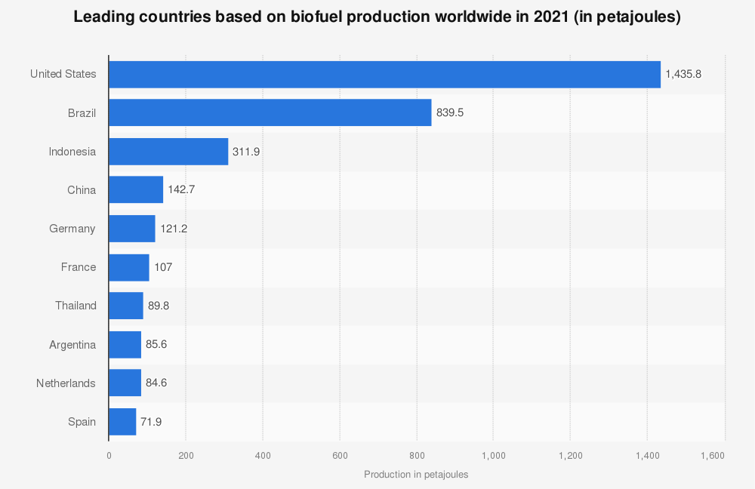
Figure 7: shows algal biomass production in European countries, with USA being the largest producer of all the countries

Implementation Strategy:
- Initial Assessment: Conduct an in-depth assessment of air pollution levels in Karachi, focusing on major pollutants and their sources, as well as the specific requirements for photo bioreactor implementation.
Along with the environmental measure, discovery of indigenous species of Spirulina for the purpose or to optimize the existing strain for its application in the process.
- Design and Engineering:

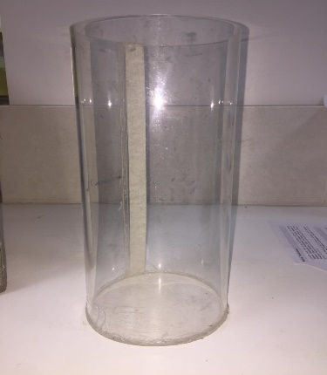
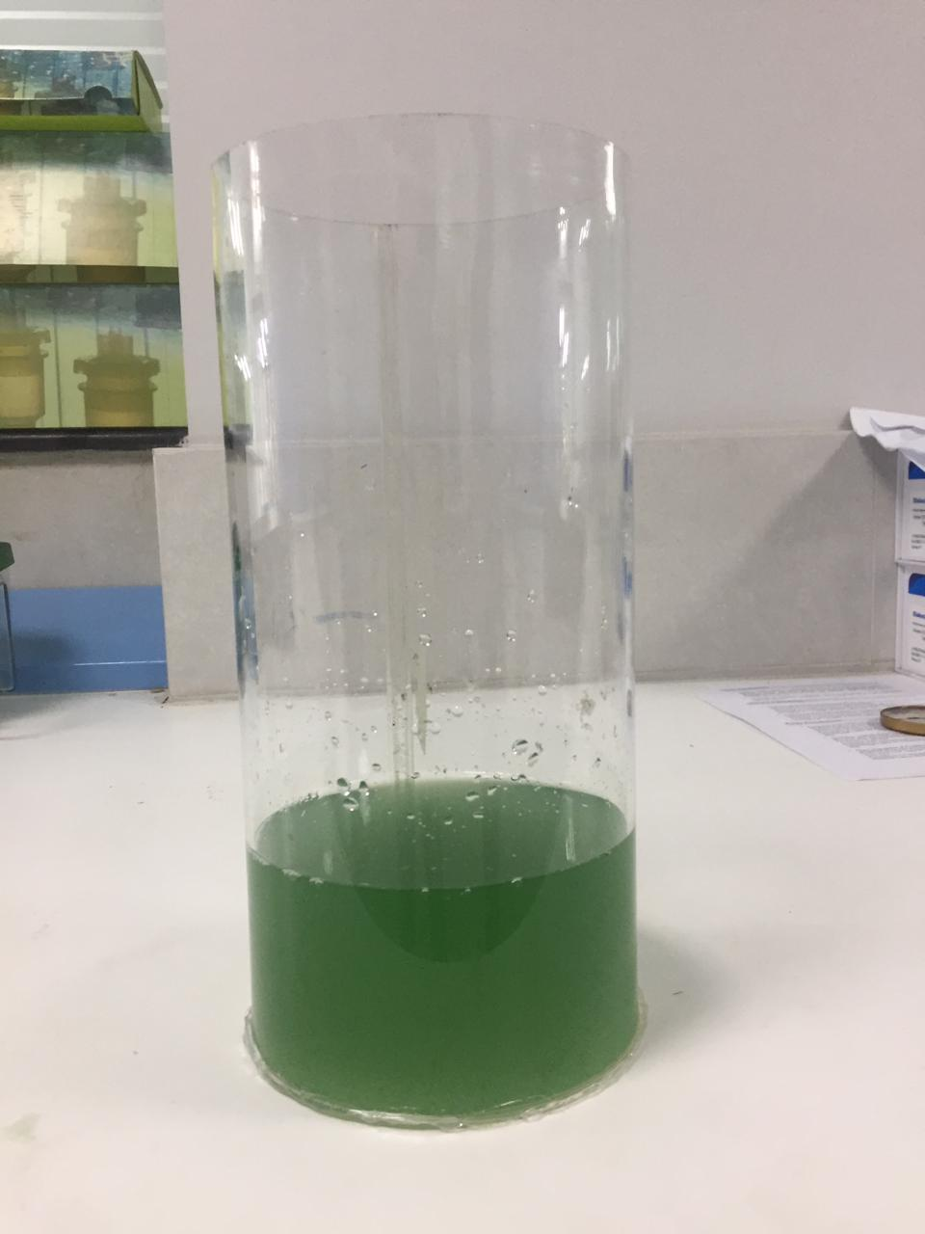

(A) (Ά)
Figure 3: shows A, represents the acrylic cylinder which is used as the base of the bioreactor. Figure Ά is the cylinder consisting innocula.

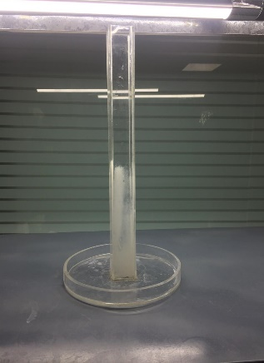
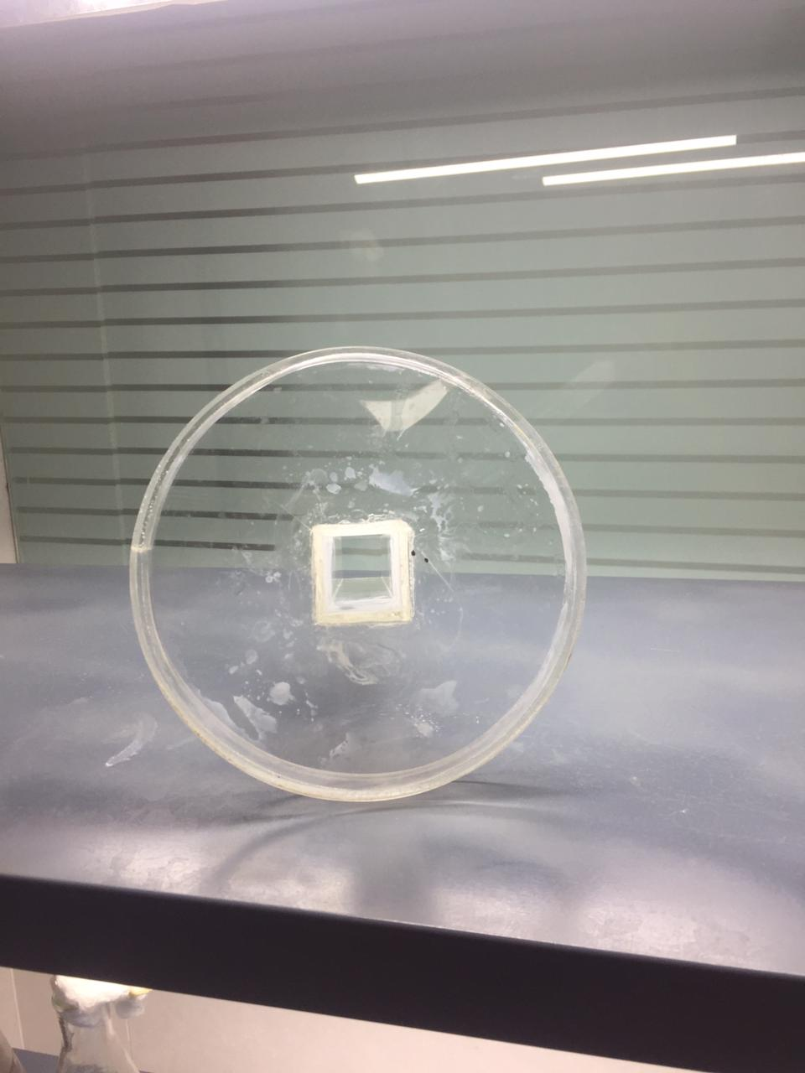

(B) (C)
Figure 2: shows B, represents the lid of the cylinder consisting of a hollow space in between for the attachment of a jacket made of same material as shown in figure C that act as the covering for the light source, which would enable the light to penetrate and provide an equal distribution throughout the innocula. It is designed as such keeping in mind that the growth of the strain or biomass is directly related to the CO2 conversion into O2.

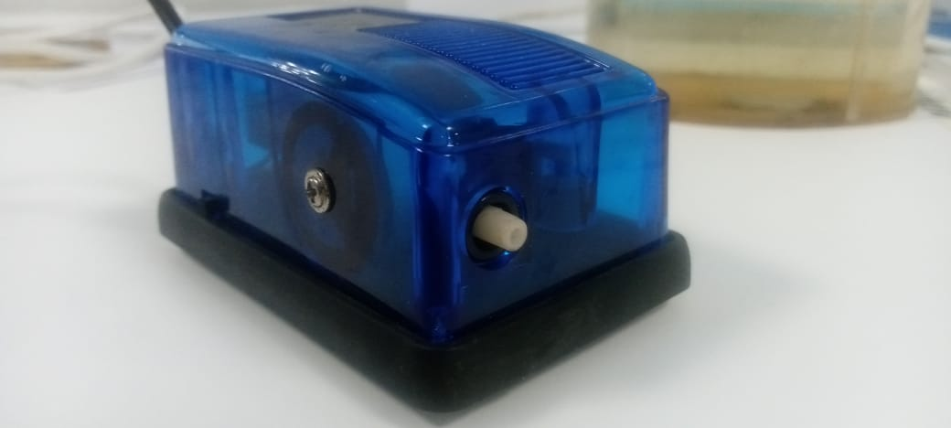
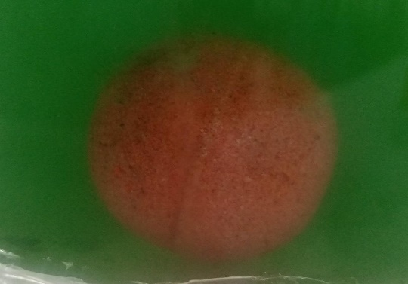

Figure 3: Aeration pump coupled with sparger is used to mix the inoculum homogenously at a constant rate in order to ensure the strain viability and activity

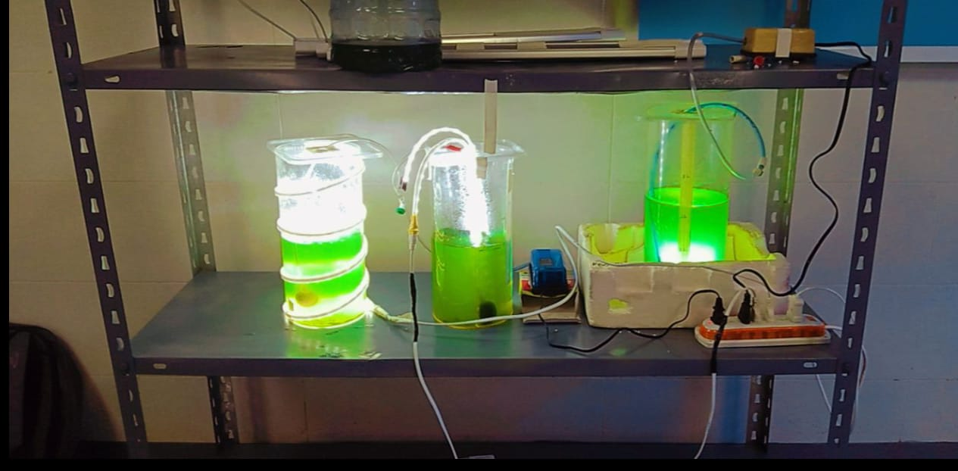
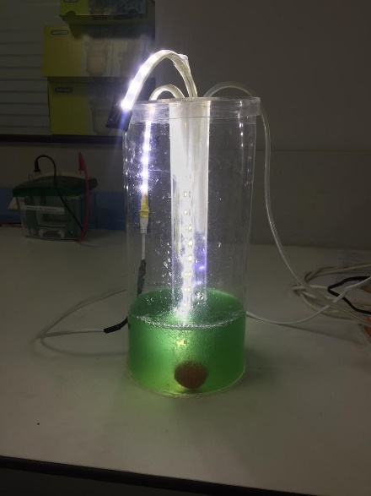
Figure 4: Following figure illustrates different arrangements of the lights in bioreactor in order to study the optimal arrangement producing greatest amount of biomass which was detected through OD. Cylinder to the left shows spiral arrangement of lights, the one in the middle had centrally located light enclosed in acrylic sheet whereas to right had the light source placed at the bottom of the cylinder.
Figure 5: Best results were observed in the cylinder with the centralized light source which was interpreted by the the biomass production compared to the other two cylinders
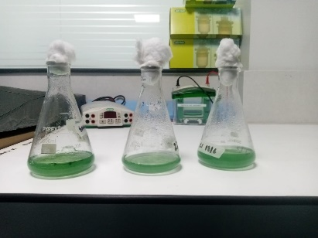
- Scaling Up: Up scaling of the spirulina culture will go through, initially on lab scale, carrying to pilot and then finally toward commercialization.

Figure 6: shows the lab scale production of the culture from 250ml to 500ml flasks.
The up scaling of the strain was conducted on the basis of the purity of the culture throughout coupled with the daily observation of biomass production through spectrophotometry.
- Pilot Project: Implement a pilot project to test the feasibility and efficiency of photo bioreactors in a selected area of Karachi, monitoring pollutant removal rates, biomass production, and environmental impact.
e. Stakeholder Collaboration: Collaborate with government agencies, environmental organizations, research institutions, and the private sector to garner support, secure funding, and ensure the long-term sustainability of the project.
f. Public Awareness and Engagement: Launch a comprehensive public awareness campaign to educate and engage the local community about the benefits of photo bioreactors and the importance of their active participation in mitigating air pollution.

Budget and Funding:
A detailed budget and funding plan will be developed during the project implementation phase, accounting for equipment procurement, installation, operation and maintenance costs, research and monitoring activities, as well as community outreach initiatives. We anticipate seeking funding support from government grants, corporate sponsorships, and international environmental funds.
Budget Table:
Personnel Costs |  |  | PKR
Element | Per Month Salary | Duration (months) | Total
Faculty member / PI Name
Dr. Faiza Nadeem, Dow University of  Health Sciens, Ojha campus | 55,000 | 12 | 660,000
Total Faculty Costs | 55,000 |  | 660,00
Other Personnel
Research Assistants: (BS/ MS/MPhil) equivalent to lecturer | 40,000 | 12 | 480,000
Research Assistants: (BS/ MS/MPhil) equivalent to lecturer | 40,000 | 12 | 480,000
Total Other Costs | 80,000 |  | 960,000
Total Personnel Costs | 135,000 |  | 1,620,000
Equipment, Consumables, and Service
Costs
Equipment | Specification | No/ Qty | Unit Cost | Year – 1  Total Budget
Pipette gun |  | 1 | 30,000 | 30,000
Micropippette | 100-1000 ul  10-100 ul | 2 (each) | 58,000 | 174,000
Total Equipment Cost |  |  |  | 204,000
Consumable/supplies
Lab chemicals |  | 10 | 10000 | 100,000
Glass ware | Flaks (250mL-1L) | 10 | 5000 | 50,000
Disposables | Micropipette tips | 20 | 1000 | 20,000
Total Consumable Supplies |  |  |  | 170,000
Photo bioreactor Construction Cost | Description | No/ Qty | Unit Cost | Year – 1  Total Budget
Acrylic based cylinder | 2L-4L | 15 each | 2000 | 60,000
Support Base (Acrylic) |  | 15 | 2500 | 38,000
Customized lid and rod |  | As per cylinder mentioned | 2000 | 60,000
Aeration pump |  | 15 | 2500 | 38,000
Sparger |  | 30 | 100 | 3,000
Pipes | 10 feet |  |  | 5,000
Light source (LED strips) | 20 meter |  |  | 10,000
Total Construction Cost |  |  |  | 214,000
Strain development Cost |  |  |  | 236,000
Management Cost for organizing national level conferences, workshops, or seminars | patent filing |  | 1 | 30000
Travel Cost | Per visit cost |  | No. of visits | Year – 1  Total Budget
Local Travel Cost | 2000 |  | As per need | 50,000
International Travel |  |  |  | -
Total Travel Cost |  |  |  | 50,000
Total Budget |  |  |  | 2,524,000

Conclusion:

In conclusion, the implementation of photo bioreactors as air purifiers holds significant potential to address air pollution issues in Pakistan, specifically in Karachi. By utilizing this innovative technology, we can achieve higher pollutant removal rates, overcome limitations associated with traditional plantation methods, and contribute to a cleaner and healthier environment.
We are confident that the proposed project will pave the way for a sustainable and effective solution to air pollution in Karachi, serving as a model for other cities in Pakistan and beyond. We look forward to discussing this proposal further and working together to make a positive impact on air quality in Karachi

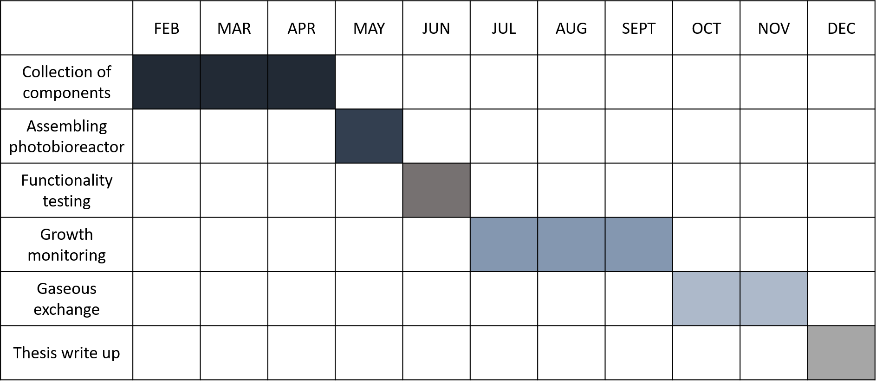
TIMELINE:

