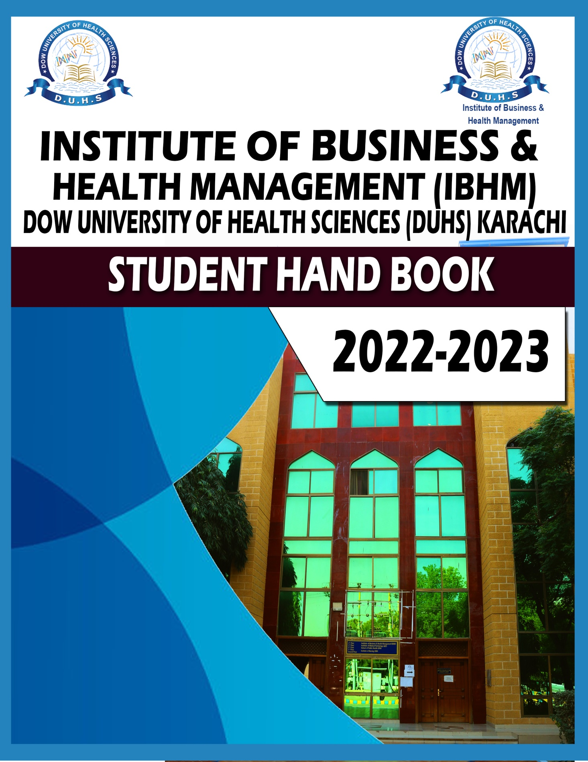

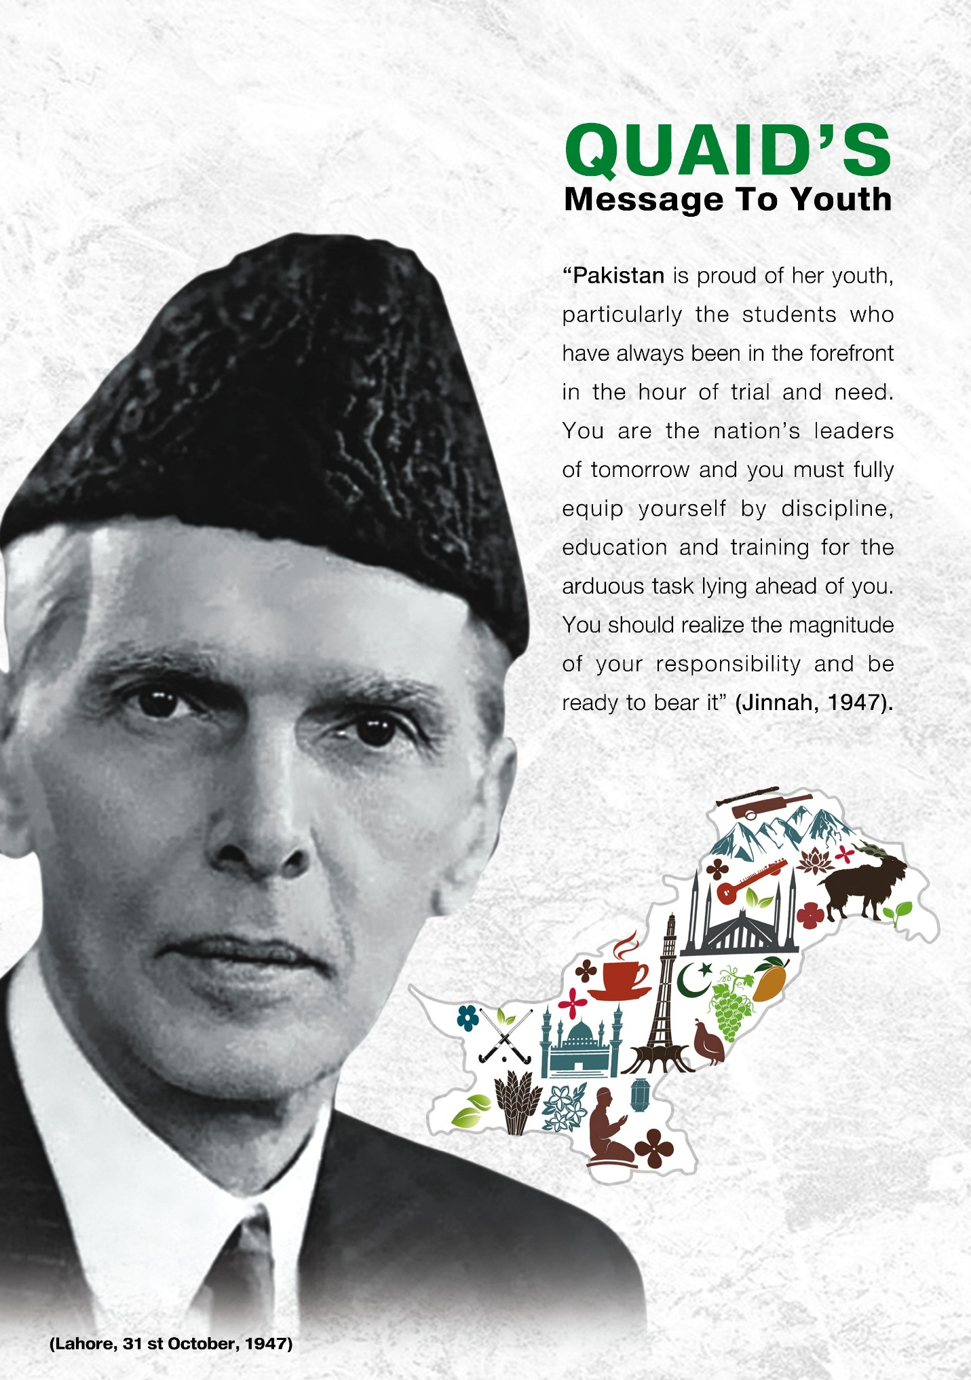

Complied By: MS. HUMERA ASRAR

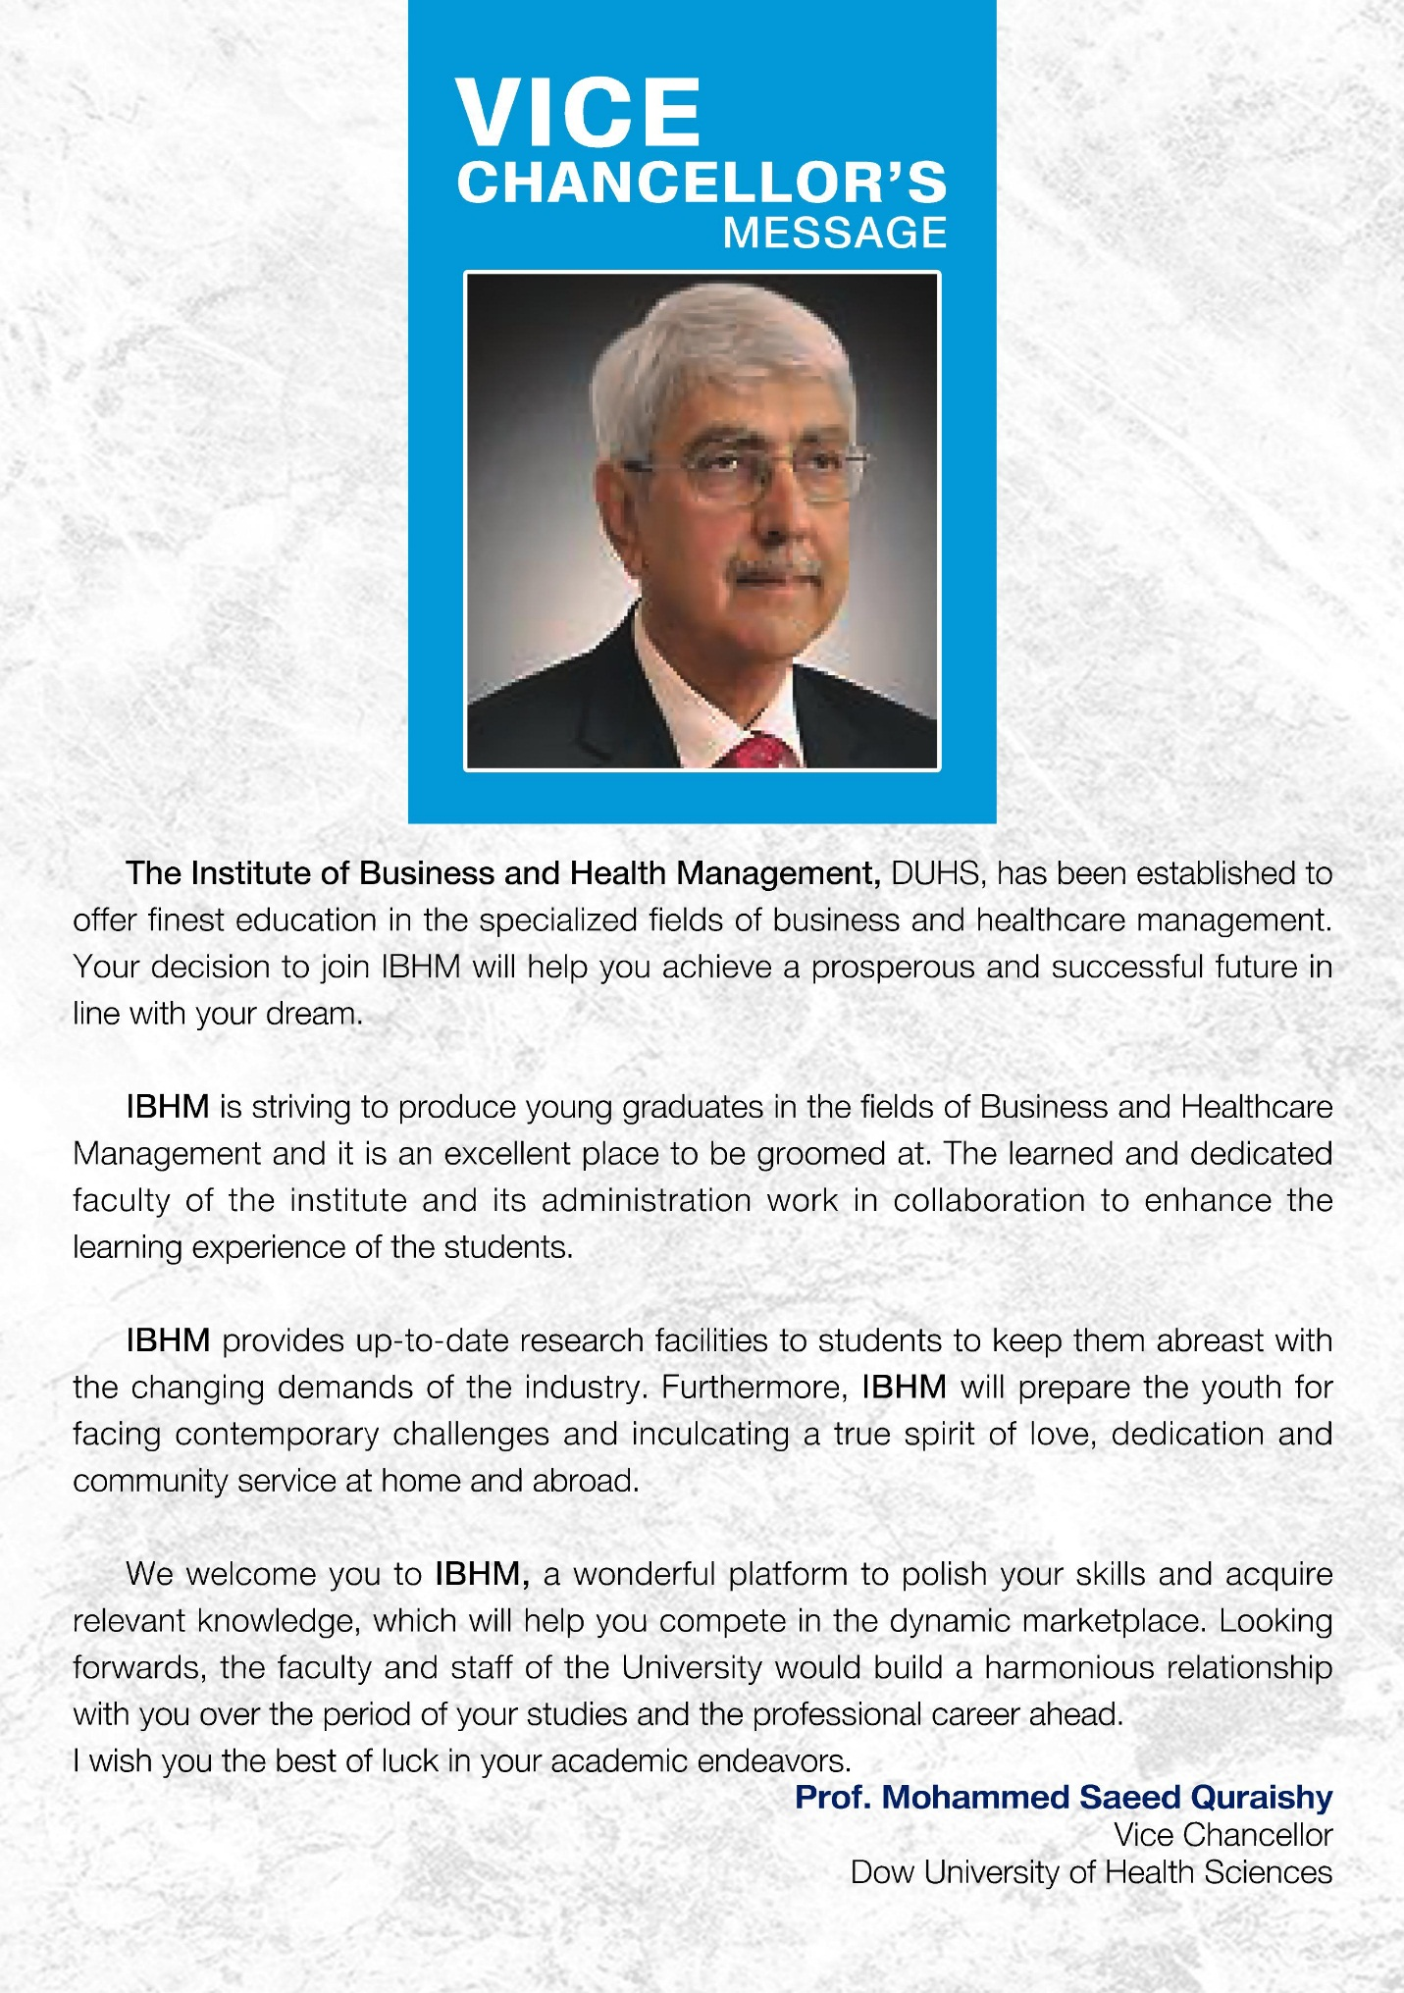

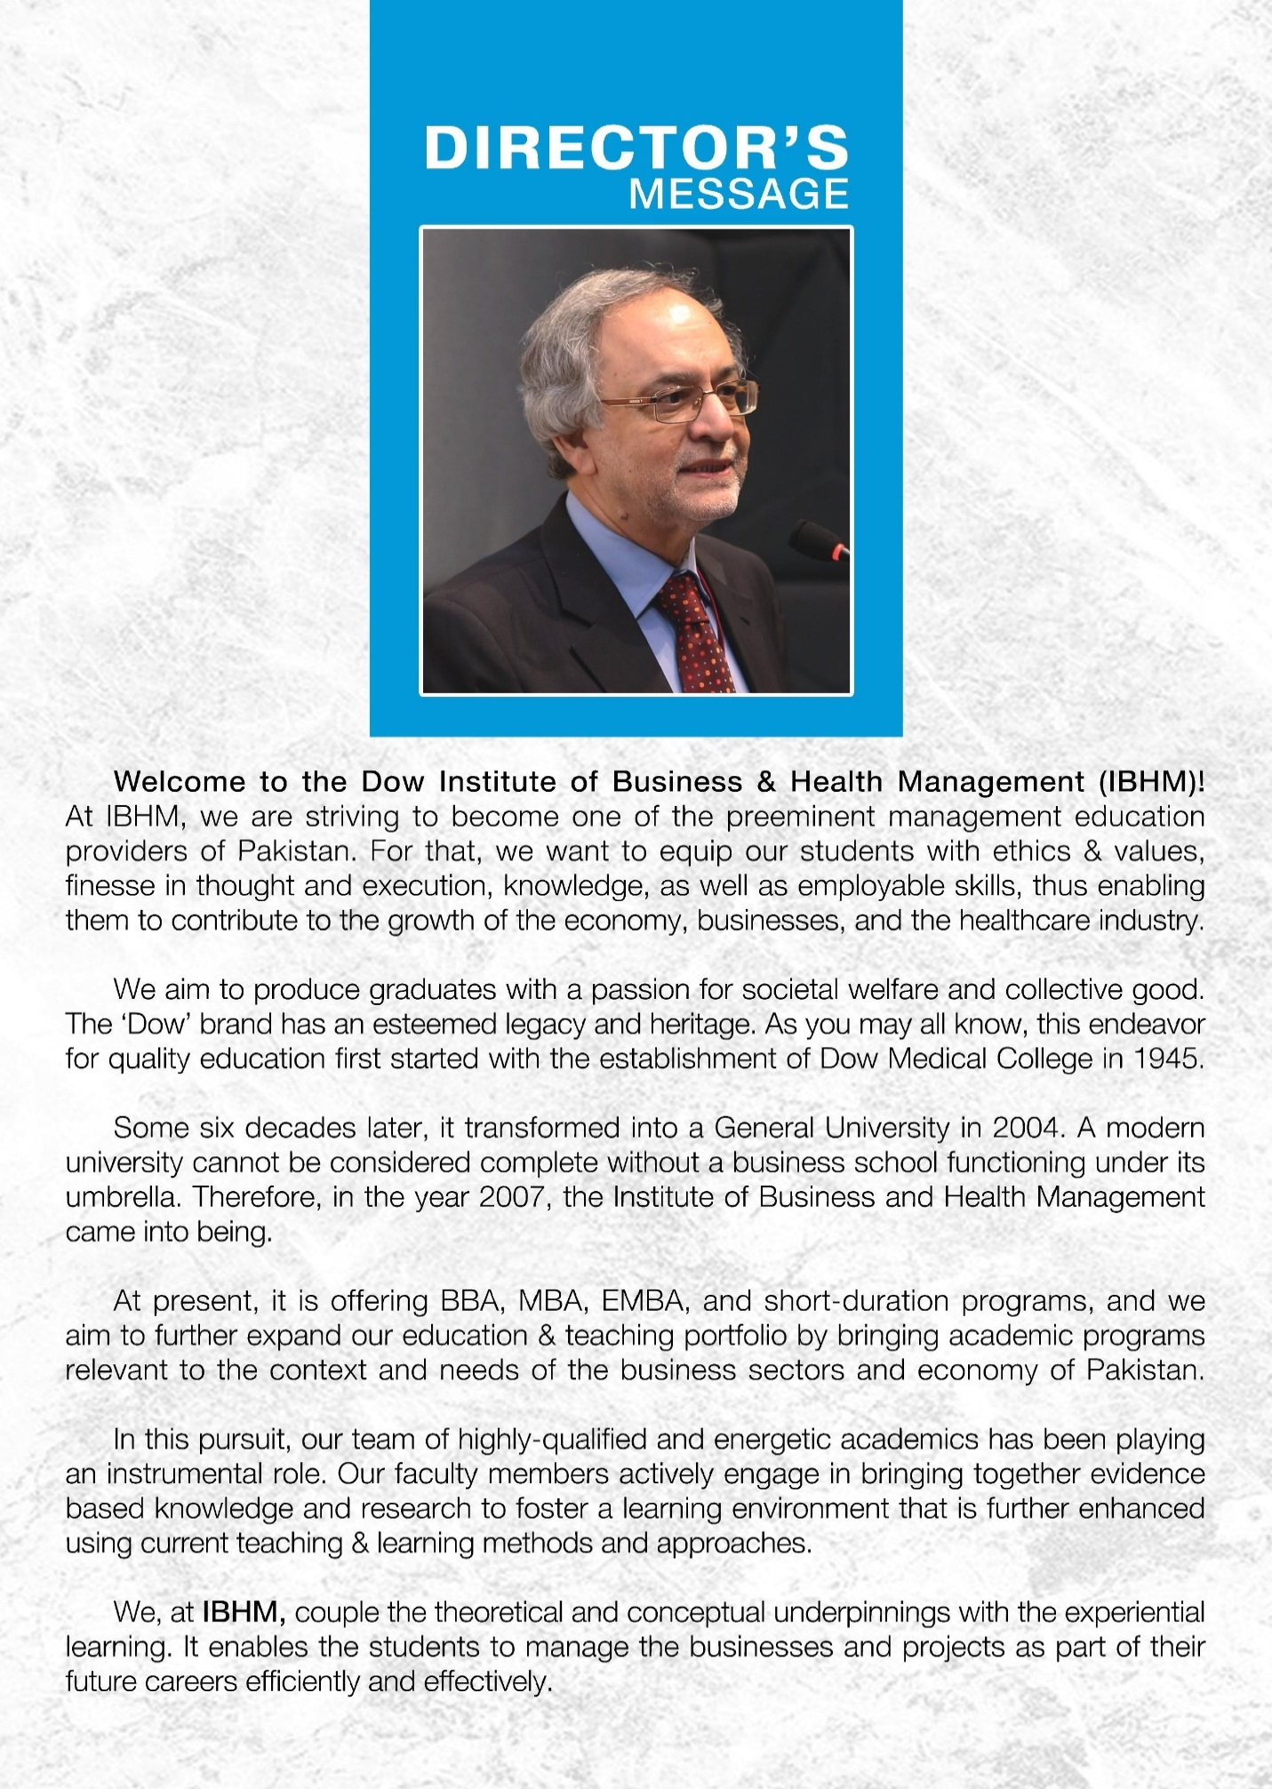

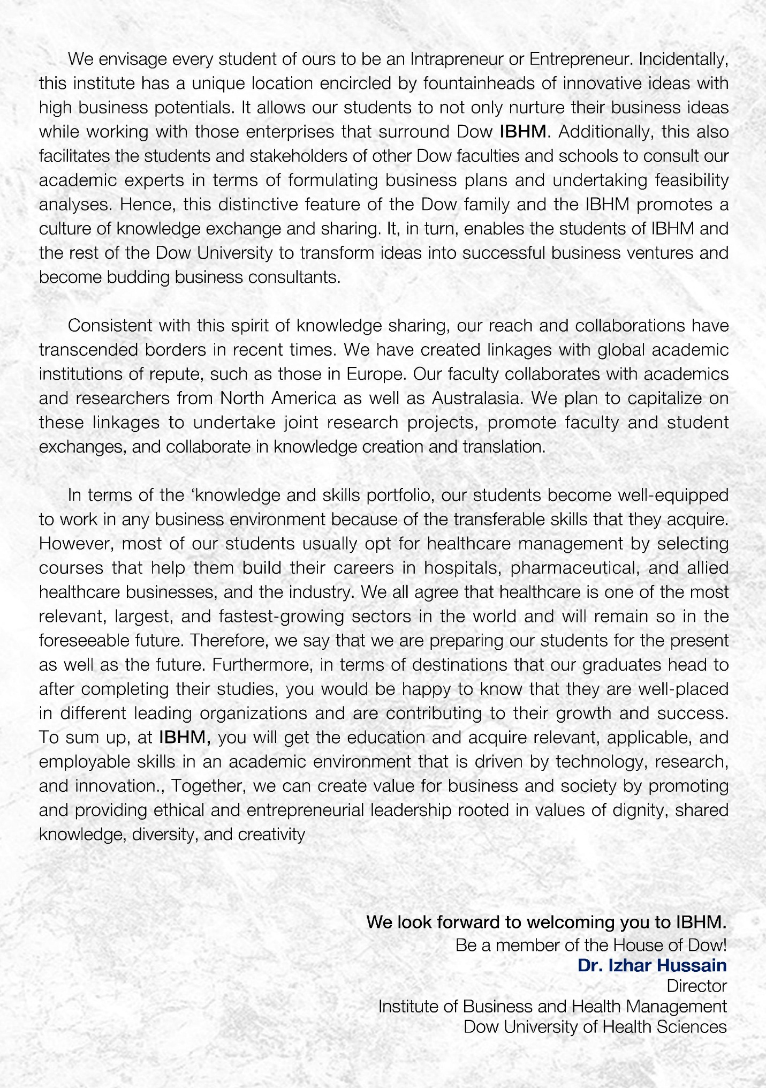

Table of Content
Contents
OUTLINE OF SERVICES 8
INTRODUCTION OF INSTITUTE OF BUSINESS AND HEALTH MANAGEMENT 10
REGULAR FACULTY 11
VISITING FACULTY 14
ACADEMIC GUIDELINES 17
Enrolment Policy 17
Fee Policy 18
Credit Transfer Policy 19
Semester Freezing Policy 19
Fall / Spring Semester 20
REQUIREMENT FOR MAXIMUM COURSE LOAD IN A REGULAR SEMESTER 20
Withdrawal / Change of Course(S) 20
Repeating Courses 21
Promotion Policy for BBA 21
Promotion policy for MBA 23
Internal Assessment 23
Comprehensive Examination 24
Retake Examination Policy 24
CGPA REQUIRED FOR DEGREE COMPLETION (UNDERGRADUATES/ MASTERS / MPHIL) 24
Cancellation of Admission 24
GRADING POLICY FOR BOTH UNDERGRADUATE AND POSTGRADUATE PROGRAMS 25
Faculty Evaluation 25
Dow Online Education System and Its Components 25
What can a student do in DOES/Team? 26
ONLINE TEACHING & LEARNING REQUIREMENTS AND POLICIES 26
Course Relevant Technological and Computing Requirements 26
Student’s visibility in the class 27
Academic Conduct 27
Academic Integrity and Honor Code 27
BBA (2-Year) Degree Program 29
BBA (4-Year) Degree Program 31
MBA (2-Year) Degree Program 34
STUDENTS’ CODE OF CONDUCT & RULES 37
Rules of Overall Conduct 37
Student Conduct Rules for Scholarships, Permissions & Documentation 38
Other Rules for Conduct of Behavior during University hours and on Premises of the University 38
a) Suspension 40
b) Suspension and Rustication of Student 41
c) Drop off/Struck off of Student from University Rolls 41
d) Student’s Disciplinary Rules & Procedure 42
e) Dress Code 42
DRESS CODE POLICY for IBHM 42
f) Rules for Library 43
g) Classroom Misconduct, Plagiarism And Unfair Means For All Degree Programs 44
h) Examples of Classroom Misconduct may include the following: 44
i) Plagiarism Policy 45
j) Attendance Policy 45
HARASSMENT POLICY STATEMENT 45
STUDENT SOCIETIES 46
Debate & Literary Society 47
Dramatics & Entertainment Society 47
Community Service Society 47
Sports Society 47
Corporate & Entrepreneurial Society 47
DOW’S IBHM TOASTMASTER’S CLUB 47

OUTLINE OF SERVICES

S.NO. | DEPARTMENT | FUNCTIONS | LOCATION
01 | Administration | All matters related to admission, enrollment, examination, and convocation. | 4th Floor, ION Building
02 | Program Office | All matters related to academic calendar, course offering, prerequisites, elective courses and other academic issues. | Program Director’s Office
03 | I.T. Lab | All IT related matters, digital library and electronic services | 4th Floor, ION Building
04 | Library | Study and learning services, borrowing of books. | 4th Floor, ION Building
05 | Placement Office | Internship, Placement and  Career Counseling, | Ground Floor, ION Building
06 | Alumni Office | Liaison between Alumni Association of Dow and IBHM chapter, and Alumni Database updating. | Ground Floor, ION Building
07 | Student Counseling | Provides students’ counseling both in academics and career pathways. | Allotted Faculty offices according to batch

VISION OF DOW UNIVERSITY OF HEALTH SCIENCES  To be a pre-eminent academic institution committed to changing and saving lives. | MISSION OF DOW UNIVERSITY OF HEALTH SCIENCES  Providing outstanding patient centered education, training and clinical care informed by cutting edge research and innovation generating and disseminating new knowledge.
VISION OF INSTITUTE OF BUSINESS AND HEALTH MANAGEMENT  To be pre-eminent management education providers by equipping students with the knowledge and skills to contribute to advancement of the business & healthcare industry, and societal benefit. | MISSION OF INSTITUTE OF BUSINESS AND HEALTH MANAGEMENT  - Provide relevant, applicable and employable business & health care management education and training.  - Maximize technology, research, innovation, entrepreneurship and intrapreneurship in the curriculum to develop future leaders.  - Create value for business and society through ethical practices.

INTRODUCTION OF INSTITUTE OF BUSINESS AND HEALTH MANAGEMENT

The Institute of Business and Health Management (IBHM) started working in 2007 as a constituent body of the Dow University of Health Sciences.
OUR VALUES
- CUSTOMER SERVICE
- EMPATHY & COMPASSION
- EXCELLENCE
- INNOVATION
- TEAMWORK
- INTEGRITY & LEADERSHIP
- RESPECT & COLLEGIALITY

IBHM is offering BBA, MBA, and Executive MBA programs in two different campuses located on prime locations of Karachi to facilitate a larger population of the community. Approximately 350 students are in IBHM in various undergraduate and graduate programs. However, more than 200 Alumnae are working in prestigious national and international business organizations.
IBHM is continuously striving to improve the learning environment through technology and innovation. In the future, the Institute is going to offer MS and Ph.D. programs in various disciplines of business and health management.
IBHM is having the following unique characteristics, which are making it more attractive for students, like

- IBHM locates amid different business ventures like Riva Water Plant, Dow General Hospital, Vaccination pant Biological Products Manufacturing Plant, Dow Diagnostic Laboratories, and so on.
- There are more chances of breeding budding business consultants as compared to other business schools due to rich different educational disciplines like school of nursing, pharmacy, medical technology, biotechnology.
- IBHM is the second educational institution that has chartered the Toast Master’s club in Pakistan to develop leadership skills in students.
- IBHM provides paid internships within Dow facilities after the successful completion of the final semester.
- DOW University has an efficient LMS to maintain a competitive academic environment and satisfy modern learning needs.
- Ehsaas need-based scholarships are available for needy students.

REGULAR FACULTY

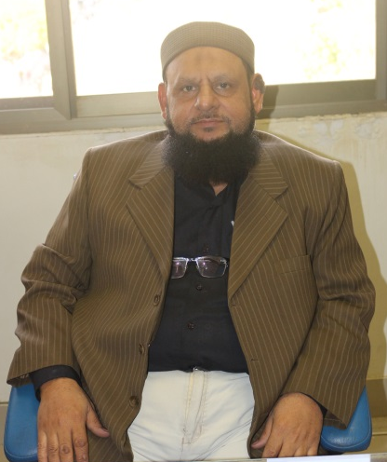
Syed Habib Ur Rehman
Program Director
Assistant Professor
MS Business Management

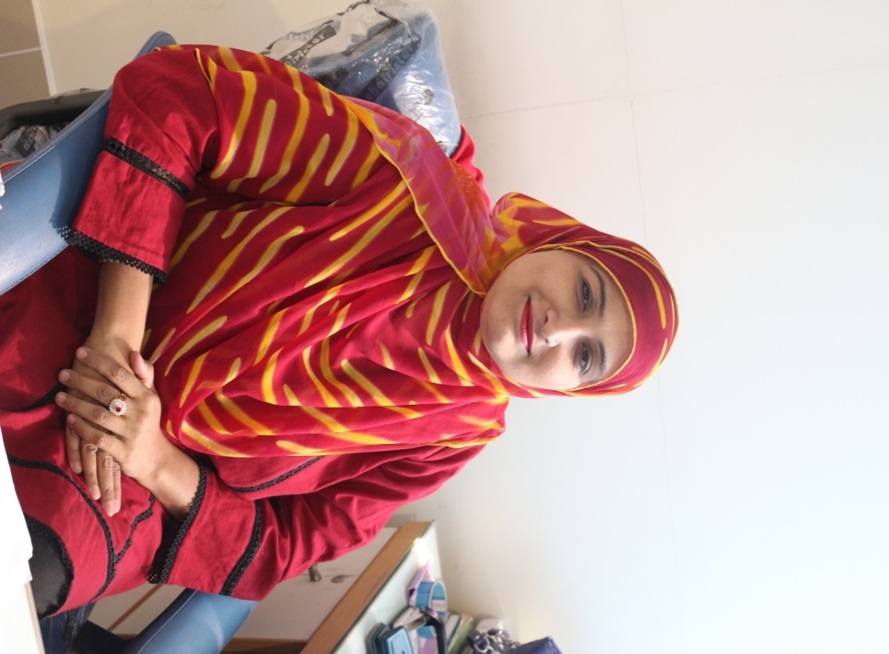Dr. Ume-Amen
HoD: Management
Assistant Professor
Ph.D. Management

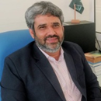
Dr. Riaz Hussain Soomro
HoD: Social Sciences
Associate Professor
Ph.D. Management

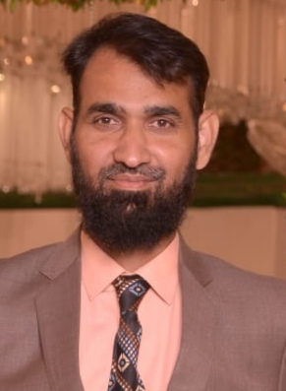
Muhammad Rizwan
HoD : Economics, Accounting & Finance
Assistant Professor
M.Phil. Economics & Finance

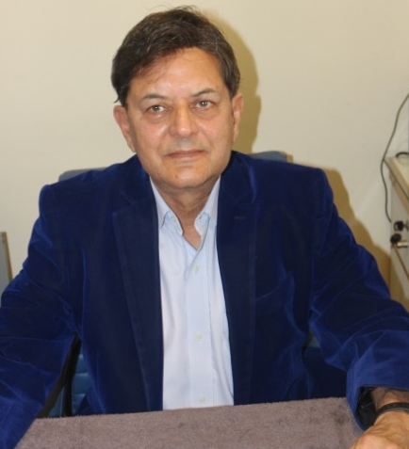
Dr. Ejaz Mian
HoD: Marketing
Associate Professor
PhD Marketing

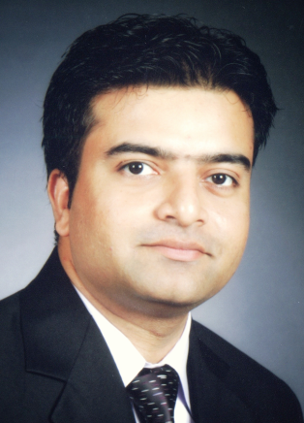
Dr. Aftab Mukhi
HoD: Health Management
MBBS (Dow); MBA; MSc PH (Lond.); DLSHTM (UK)

 | 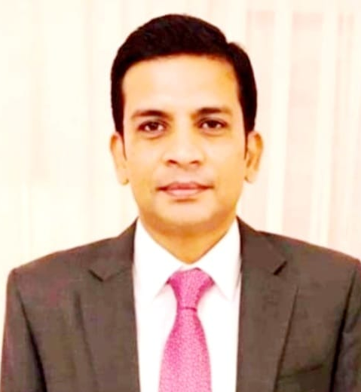 |  | 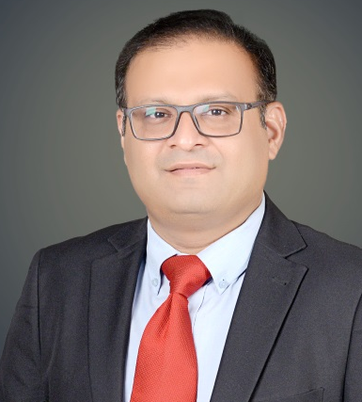
Dr. Faryal Salman  Associate Professor  PhD Marketing | Dr. Faraz Ahmed Wajidi  Associate Professor  Ph.D. Management |  | Dr. Agha Ammad  Associate Professor  PhD Finance
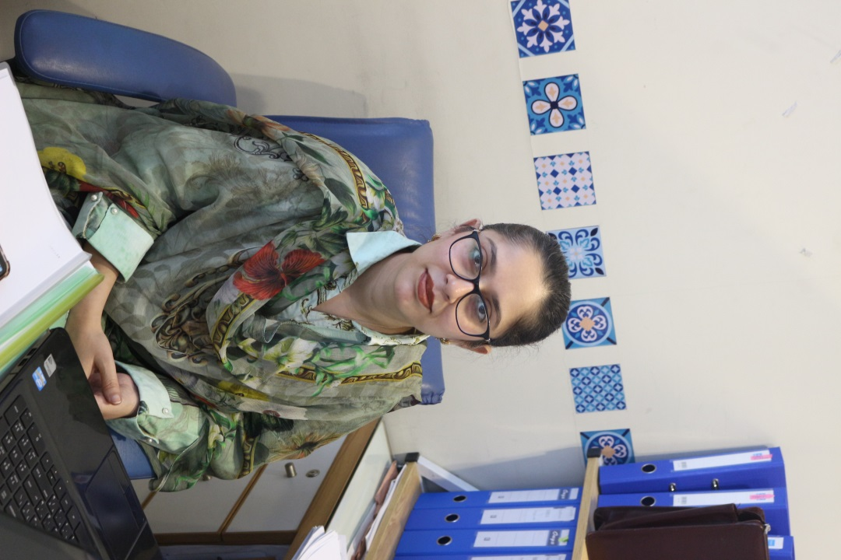  Dr. Zahra Nazim  Assistant Professor  Ph.D. Management | 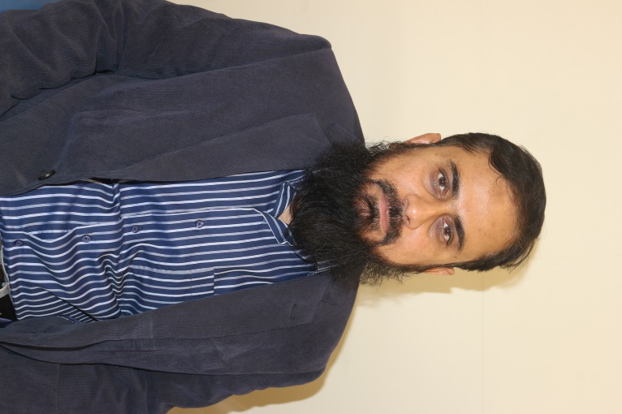  Syed Ahmed Ghayas Tahir  Assistant Professor  MS Business Management |  | 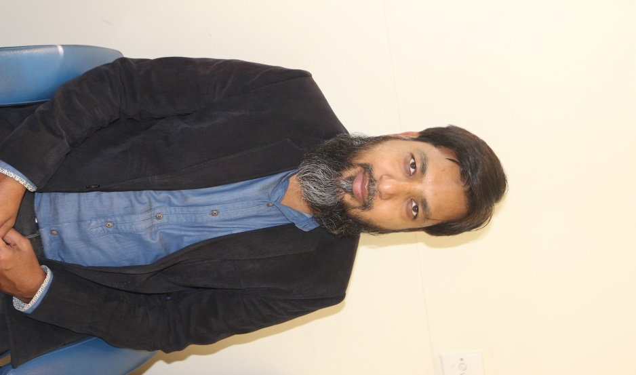  Mirza Kashif Baig  Assistant Professor  MS (SWEDEN) / PGD / MBA
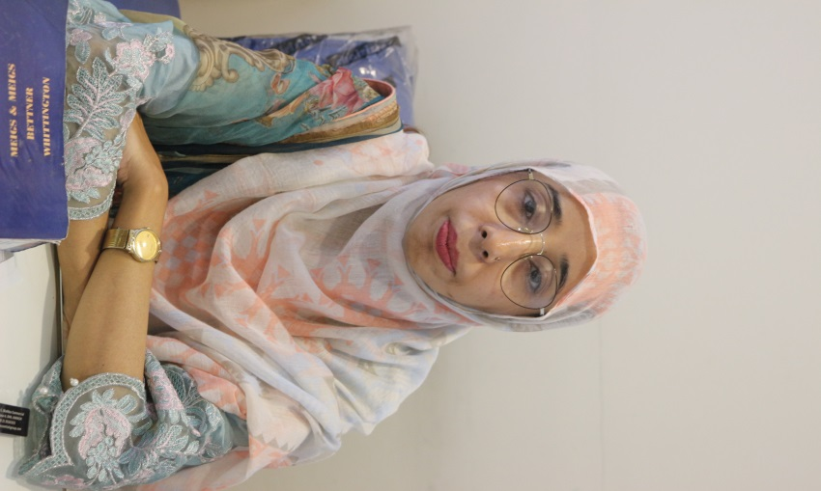 | 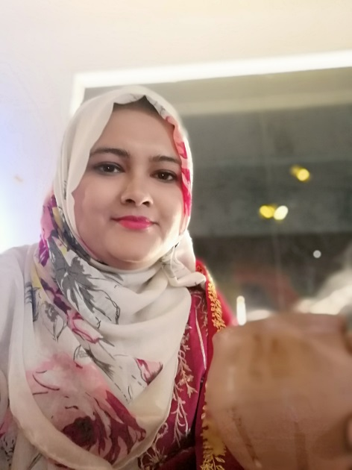 | 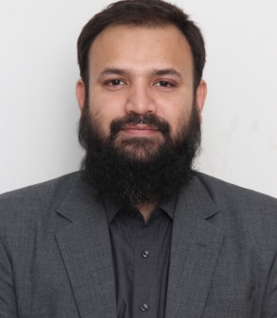
Kiran Farooq  Assistant Professor  M.Phil. MBA | Humera Asrar  Lecturer  M.Phil. Business Management | Muhammad Babar  Lecturer  MBA
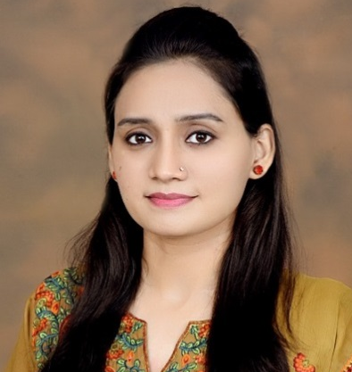  Wajiha Saghir  Lecturer  MBA / Pharm-D | 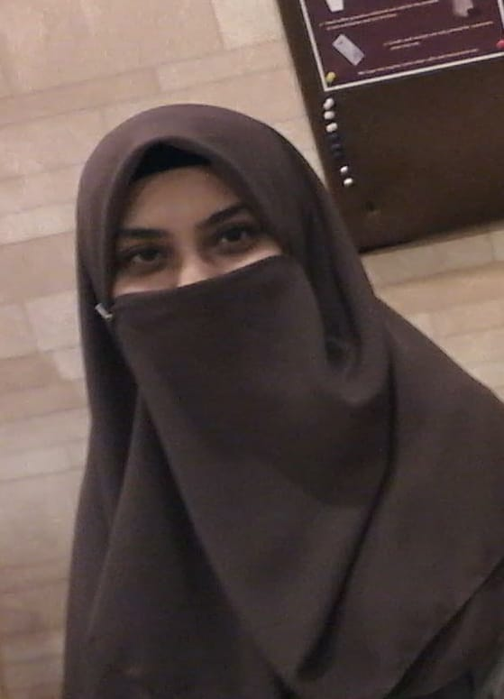  Erum Ghayas  Lecturer  MS in Business Administration | 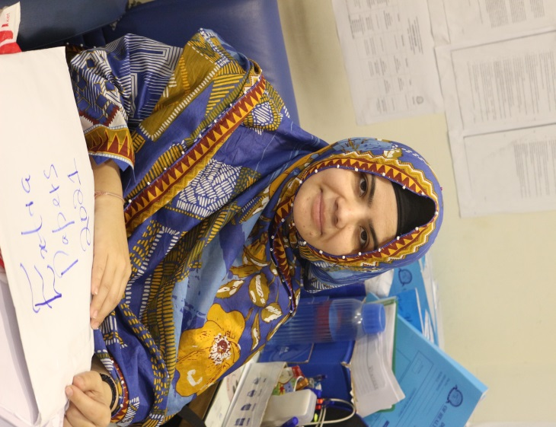  Yasmeen Bashir  Lecturer  MBA / M.ED. / M.Com
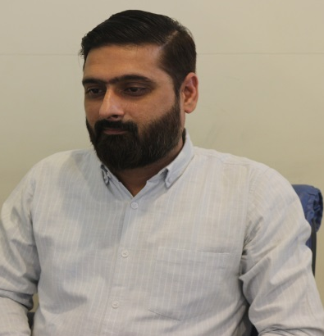
Ovais Ahmed
Lecturer
MBA

VISITING FACULTY

S.NO. | NAME | QUALIFICATION | EXPERIENCE | ORGANIZATION
1 | Zia ul Haq | MBA Finance(IBA),  MSc Applied Mathematics | 30 Years | Visiting Faculty  IBA
2 | Prof Dr. Zeenat Ismail | Ph.D. (Uok),  M.A Psychology | 40 Years | Visiting Faculty  IBA
3 | Dr. Mubashir Ali Khan | Ph.D. (China),  MS Finance (IBA) | 8 Years | Senior Assistant  Professor Bahria  University
4 | Arif Hassan | CIS, MBA  (Finance) | 6 Years | Senior Manager  Corporate Law  and Taxation
5 | Dr. Nadeem Mehmood | Ph.D. CS (Uok),  MCS | 22 Years | Associate Professor  UBIT (UoK)
6 | Dr. Akhter Raza | Ph.D. (Uok),  MSc Statistics | 15 Years | Assistant Professor  Federal Urdu University
7 | Farooq-ur-Rehman | MBA | 15 Years | Lecturer IMT DUHS
8 | Dr. Asim Zaheer | Ph.D. (Uok) | 15 Years | Assistant Professor  NED University
9 | Yasir Hashmi | B. Pharma.,  MBA | 15 Years | Worked in AKUH.  Working as an  entrepreneur
10 | Imran Muhammad Kamil | ACMA, MA Eco | 20 Years | Lecturer Premier College
11 | Sanam Soomro | MS Healthcare Management, Bachelor of Science  in Finance | 16 Years | Director Quality Enhancement (DUHS),  Marketing and Promotion Officer(USA)
12 | Syed Zulfiqar Jaffar | M.Com(HEC), BSC | 34 Years | Cost Controller  (Textile Mills Ltd),Senior Manager  (Habib Motors)
13 | Akhter Mehmood | MBA (IBA) | 30 Years | CEO, Brand Image
14 | Bilal Ahmed Chishty | MBA-Finance(KASBIT),  Finance(Malaysia) | 24 years | Assistant Professor  (IoBM), Lecturer  (DHA Suffa University)
15 | M. Noman Quadri | LL.B(UOK),LL.M  University of  Pennsylvania,  Law School | 13 Years | Legal Officer,(NBP),  Duty Officer and  Lead Investigator(USA)
16 | Mukesh Kumar Kella | B.E(Civil Eng.),  MBA(IBA), MS,  PhD.(SZABIST) | 22 Years | Conducting Trainings,  Lecturer(UoK)
17 | Dr. Syed Abbas Ali | PhD  (NED) | 21 Years | Professor(NED)
18 | Dr. Usman Ghani | MPA(UoK), PhD  (UoK) in HR | 6 Years | HR(DHA)
19 | Arif Kamal | MCS (KU) & MS (HU) | 21 Years | Visiting Faculty(NED),  Lecturer(Hamdard Uni),  Visiting Faculty(DUHS),  Assistant Professor  (SBB Dewan Uni)
20 | Dr. Musarrat Adnan | PhD (Economics) KU | 20 Years | Dean Greenwich university
21 | Dr. Seema N. Mumtaz | MBBS & MBA | 30 Years | HoD Community Health Sciences, NUMS, Karachi.
22 | Dr. Riaz Ahmed | PhD Islamiat Federal Urdu University | 10 Years | Immam o Katib, DUHS, Karachi
23 | Shahid Naved | MS(Business Management)  Hamdard University | 20 Years | Assistant Professor, Hamdard University
24 | Mohsin Mushtaq Chandna | MA (University of Chicago) | 12 Years | Secretary, Ministry of Inter Provincial Coordination,  Former Special Secretary Ministry of Finance, Government of Pakistan.
25 | Dr. Mirza Jawwad Baig | PhD(ISPA UOK) | 22 Years | Professor (UOK)
26 | Erum Fatima | MA(English)  Jinnah University | 21 Years | Lecturer DUHS
27 | Yawwar Abbas Farishta | MBA in Marketing from  IBA | 27 Years | CEO and SBP at Innovata Healthcare, Strategic Business Partner and Consultant of Wilshire
28 | Dr. Ziafat Ali | MBBS  (Sindh University Jamshoro) | 24 Years | Medical Superintendent  Alkhidmat Healthcare Karachi

ADMINISTRATIVE STAFF
S. NO | NAME OF STAFF | QUALIFICATION | RESPONSIBILITIES
1 | Hassan Khan | B.A | Admin. Officer, admissions , examination and maintenance of IBHM
2 | Asim Mahmood | MBA | Coordinator (For Non-Degree Programs)
3 | Shujaat Khan Ghaznavi | M.Com | Accounts , Finance , Scholarships and Placement,  Alumni Affairs
4 | Amber Ahmed | MA  (Library Science) | Librarian
5 | Muhammad Faizan | B.Com | Admissions/enrollment/CMS
6 | Muhammad Asif | Masters in Arts (MA) | PA to Director, BBA Registration, On line classes of morning shifts
7 | Sajila Sabir | MBA, BSC | Online classes of Evening/Weekend programs.
8 | Umme Rabab | BSC | Coordination of students’ research projects, attendance of morning shift
9 | Syed Muhammad Salman | Intermediate | I.T Lab and online/on campus classes.
10 | Kamran Ali Soomro | B.com | Dispatch work and record-keeping (morning shift)
11 | Aurangzaib | Intermediate | Dispatch work and Record Keeping (evening shift)

ACADEMIC GUIDELINES

Enrolment Policy

- “No student shall be eligible to appear at any University Examination without enrolment with the University on payment of the prescribed fee.

- Application for enrolment on prescribed form supported by the required certificates will be submitted to the Controller of Examinations through the Program Director within six weeks of the date of admission in the case of normal admissions, and three weeks in the case of admission by transfer. Necessary payment/ fees will be charged with each application.

- Each student shall receive an Enrolment Card, with a unique enrolment number. If an Enrolment Card is lost or destroyed, its duplicate copy will be issued on submission of affidavit and payment of a prescribed fee.

- No application for admission to a University examination or any other purpose shall be received from an enrolled student unless the enrolment number is quoted in the application.

- A student shall be assigned an enrolment number for identification throughout his/her stay at the University for the duration allowed in the course duration policy.

- However, a student unable to complete his/her diploma / degree requirement within the validity of his/her enrolment will have to re-validate / extend the enrolment due to semester freezing for not more than two (02) years by paying a prescribed fee (footnote “the student should check with program office of IBHM for the current prescribed fee) with the recommendation of the Program Director and with permission of Director IBHM and Chairperson of Department of Postgraduate Studies, as per the HEC criteria.

- Extension of re-enrolment will be allowed by Vice-Chancellor on the recommendation of Program Director and Chairperson of the Department of Postgraduate Studies as last chance for those students who are short of aggregate/short of CGPA or fail in a maximum of two courses only. The Program Director will initiate the process by putting up all such cases to the Director IBHM for further action.

- A student cannot be enrolled in two different full-time courses simultaneously.”

Fee Policy

- University shall charge fees under the following headings:
  - Admission Fee
  - Tuition Fee
  - RFID Card Fee
  - Enrolment Fee
  - Examination Fee
  - Thesis Defense Fee
  - Any other Fee that may be applicable
- Fee once paid will not be refunded under any circumstances.
- Fee for the postgraduate/Undergraduate program will be paid course wise.
- The fee for the first semester, admission fee, and RFID card fee will have to be paid at the time of admission. The Admission offer is valid for 15 days only. If the student fails to pay all fees and dues of the first semester within 15 days, the admission will be canceled. The next candidate on the merit list will get the offer for that seat.
- For subsequent semesters’ fees and dues, if not paid within time, shall be liable to late payment fee as per the University Rules.
- In subsequent semesters, if a student fails to pay his/her fee and dues within 30 days, his/her name will be struck off from the institution.
- No student will be allowed to appear in any examination unless s/he has cleared all dues of the University.
- Enrollment fee has to be paid separately.
- Fee may be increased by 10% every year.
- The fee and rules/regulations may be revised by the University at any time during the course of the study.

Credit Transfer Policy

- The application for transfer of credit from an HEC University or any foreign university program shall be made at the time of entry into the IBHM program.
- Maximum of 50% of total course contents of any program can be credited.
- The contents of the course for which the credit shall be given have to be identical or majority similar to the one of IBHM, to which the credit is transferred.
- The students who request for transfer of credit are responsible for providing an authentic certified copy of the course contents from the institute where they studied the courses.
- Only courses that have been taught face to face more than 50% of the time can be transferred.
- The students should have got a minimum grade ‘B’ in the transferred course.
7. IBHM may ask the students to take a challenge test prior to giving credit of the transfer. The course whose credit has been transferred from another course will be mentioned in the marks sheet (transcript) as a transfer course.

Semester Freezing Policy

A student may take a semester off due to unavoidable circumstances (e.g. Financial / Health constraints etc.) by applying for a Semester Freeze. Such student must submit an application, verified by the Program Director & recommended by the Director IBHM.
The University does not allow freezing during the first semester.
- Request regarding Semester Freeze should be made prior to commencement of the Semester.
- If a student freezes a semester(s), s/he will retake admission in the same semester, will pay full tuition fee of that semester but not admission fee.
- The maximum duration of the degree program shall remain the same.
- The student shall pay 10% of the tuition fee of each Frozen Semester for continuation of enrolment.
- Once approved, the information regarding Semester Freeze shall be given to the following from the administration of IBHM:
  - Controller of Examinations
  - Director Admissions
  - Registrar, DUHS
  - Program Director, IBHM
  - Department of Postgraduate Studies
6. Freezing for not more than two (02) semesters by paying a prescribed fee with the recommendation of the program Director and with the permission of Director IBHM and Chairperson of the department of post graduate studies, as per the HEC Criteria.
7. “Extension of re-enrolment will be allowed by the Vice chancellor on the recommendation of Director IBHM and chairpersons of the post graduate studies.”

Note: The student should check with program office of IBHM for the current prescribed fee.
Ref: Duhs- Postgraduate Academic Policies – 2018, Academic Council Meeting Ref. No: Duhs/2018/10/Ac-15(2) Dated 13.10.2018

Fall / Spring Semester
There will be two regular semesters (Fall and Spring) in one academic year. Each semester will be spread over 16 - 18 weeks (inclusive of 1 – 2 weeks for examinations).

REQUIREMENT FOR MAXIMUM COURSE LOAD IN A REGULAR SEMESTER

1. An undergraduate student may be allowed to take up to 18 credit hours and, a graduate student up to 12 credit hours (being maximum course load) only if s/he has a C.GPA of 3.5 or above and that too with the recommendation of Program Director and permission of the Director IBHM.

2. The Director may also allow maximum course load to any student, graduate or undergraduate when the student is graduating in that very semester, e.g. an undergraduate student with C.GPA of 3.2 needs 18 credit hours to graduate or a Masters / MPhil student with a C.GPA of 3.2 needs 15 credit hours to graduate. In this situation, the director can make an exception for any particular student by allowing him / her to take maximum course load as this will be the student’s last and graduating semester.

Withdrawal / Change of Course(S)

- A student, with the consent of the concerned Director IBHM, may be allowed to (a) change a course within 7 days of the commencement of a semester, and (b) drop a course within 2 weeks of the commencement of semester.

- Withdrawal from a course will be allowed latest up to one week before the 2nd in-semester examination (i.e. by the end of 15th week) under approval by the Director IBHM. Withdrawn course will appear on transcript with the letter grade W, and will not be treated as F grade.
- There will be no supplementary/special examination in the semester system, If a student fails in a course, he/she shall repeat it by attending the course and passing the examination.

Repeating Courses

- Whenever a student fails or gets an ‘F’ grade, s/he has to repeat the course, whenever offered.

- Undergraduate students may be allowed to repeat a course in which s/he has obtained Grade ‘D’

- The Institution may define a maximum number (≤6) of courses that student may be allowed to repeat.

- In case a student repeats the course which has already been taken, the old grade will be substituted with the new grade, (for CGPA calculation), but in case a student takes a new course instead of the course in which s/he failed, both the grades will reflect on his/ her transcript i.e. old course grade and new course grade.

- The student will pay the fee for the course and attend all the classes, undertake internal assessments, mid-term and final examinations.

Promotion Policy for BBA

1. Minimum 2.0 CGPA is required for award of degree in the undergraduate program and a student must maintain at least CGPA 1.7 in one semester to be considered eligible for promotion in the next semester.
2. The students acquiring GPA 1.70 and above, but failing in any paper(s) will be promoted to the next semester conditionally that he/ she will pass the course in the re-take examination, or in the next semester's retake examination, with the requirement to attend all the required classes in the next semester; furthermore, with maximum attempts for retakes to be defined as no more than 4 overall, availed or unavailed. This is applicable to the candidates in the 1 and 2nd years of a 4-year Bachelors program of study.
3. Therefore, number of attempts allowed to clear a course/subject/paper in the 1st and 2nd year program of study will be 4.
4. After utilizing full number of attempts, even missed attempts, and the subject not cleared/passed, will be the ground for the student to be dropped out of the program of study by the Principal/Director; however, student may re-enroll in another program or in the same program in the next admission cycle, through the advertised merit process of admissions, as per DUHS rules and procedures.
5. Also, a student who secures less than 1.70 C.G.P.A. in the preceding two semesters will not be promoted to the next semester/ next year; however, the student may be eligible to appear in the re-take examination, or the regular examination, in order to pass the course and improve his/her G.P.A, when the examination of that course(s) is to be conducted/held, in which he/she is failing in the next academic session/semester/year, as per the academic calendar of the program of study. Full course fees would be charged to the student, as per DUHS rules for the number of courses taken in each semester, including failed or remedial courses.
6. In addition, it is understood that the University is not required to offer all courses in each semester and the course may be offered in the next academic session, as per curriculum plan of study.
7. Students' full academic performance will also be considered when they are re-taking the course (with a less than 1.7 CGPA in the previous two semesters), and the student has to maintain and get at least minimum required marks in Tests, Practical, Projects, Thesis, Assignments, Mid-term Test and Theory Papers aggregate.
8. Minimum attendance as per University policy will be ensured in that immediate next session for the re-taking of the class.
9. After utilizing all 4 attempts, student is considered automatically dropped from the University program of study, a notification of which will be issued by the Principal/ Director of the BS program to inform the student upon announcement of result.
10. However, s/he will be eligible to seek re-admission. Re-admission will be allowed only once during 4 years BS degree program, as per admissions procedure of the University. Student must meet all regular requirements for re-admission and is not considered automatically re-enrolled, foregoing the merit process.
11. Readmission will be allowed after the payment of full admission fee and the student will be considered as an external candidate with others, and admitted as per merit list.
12. For the award of degree, the student must have a minimum C.G.P.A. of 2.0 in the undergraduate program, and completed all requirements in the maximum duration of the program.
13. Maximum duration of validity of enrollment in a 4-Year undergraduate program of study is defined as 8 years.

Promotion policy for MBA

- Where the program consists of many non-core courses, student may be allowed to the next semester s/he cleared 80% of the courses of the previous semester.
- S/he will have to join the failed course on the earliest occasion, whenever the University offers this course.
- Clearance of the core courses is however mandatory for promotion to the next semester. (e.g. 8 courses out of 10) in Semester Examination.

- Final exam will be conducted by the Examinations Department, DUHS as per pattern decided by the University.

- Student will have to pass both the internal assessment and semester examination (obtain minimum of 63% marks in each for undergraduate/postgraduate program, in order to pass that course. However, student who fails to obtain 63% marks respectively in internal assessment will be re-assessed with the final examination.

- There will be no Supplementary/ Special Examination in a Semester system; if a student fails in a course, s/he shall repeat it by attending the course passing the examination.

Ref: Implementation of Semester System in Higher Education Institutions of Pakistan
Policy Guidelines Approved by the Higher Education Commission (HEC), year, page

Internal Assessment

- This shall consist of assignments, quizzes, monthly tests, as decided by the Course Instructor.
- The method of internal assessment and schedule will be forwarded to the Examinations Department at the commencement of semester.
- There will be no re-take of internal assessment exam.
- Marks obtained shall be submitted to examination department as these tests are taken.

Internal Assessment (Quizzes / Assignments / Presentations ) | 35%
Semester / Midterm Examination | 25%
Final Examination | 40%

Comprehensive Examination

After completing the required number of courses for a particular degree, and fulfilling the requirement in terms of CGPR, a student shall pass a comprehensive examination covering all the courses studied for the degree.

Retake Examination Policy

If a student fails or gets an ‘F’ grade; s/he has to repeat the course, whenever offered. In case a student repeats the course they will have to take classes again and internal assessment will be done again.

Ref: Duhs- Postgraduate Academic Policies – 2018, Academic Council Meeting Ref. No: Duhs/2018/10/Ac-15(2) Dated 13.10.2008

CGPA REQUIRED FOR DEGREE COMPLETION (UNDERGRADUATES/ MASTERS / MPHIL)

- For graduation, the minimum qualifying CGPAs for Bachelors and Masters students are 2.00 and 2.50, respectively.
- Whenever an undergraduate student’s C.GPA decreases from 2.0, or a graduate student’s CGPA decreases from 2.5, s/he will be on 1st probation for the next semester. If the undergraduate student does not come out by increasing his/her C.GPA to 2.0, or a graduate student does not come out by increasing his / her C.GPA to 2.5, then again, s/he will go on “Last Probation”.
- If the student who was earlier on 1st probation, does not come out in the last probation by achieving the minimum desired C.GPA, s/he shall be dropped from the Institute and cannot be re-admitted by the same institute.

Cancellation of Admission

1. If a student fails to attend any lecture during the first four weeks after the commencement of the semester as per announced schedule, his/her admission shall stand cancelled automatically without any notification.
Ref: Implementation of Semester System in Higher Education Institutions of Pakistan Policy Guidelines Approved by the Higher Education Commission (HEC)

GRADING POLICY FOR BOTH UNDERGRADUATE AND POSTGRADUATE PROGRAMS

GRADE | PERCENTAGE | GPA
A | 93-100 | 4.00
A- | 87 – 92 | 3.67
B+ | 82 – 86 | 3.33
B | 77 – 81 | 3.00
B- | 72 – 76 | 2.67
C+ | 68 – 71 | 2.33
C | 64 – 67 | 2.00
C- | 60 – 63 | 1.67
F | 0 – 59 | 0.00

Faculty Evaluation

- It is mandatory for the students to evaluate the Course Instructor on what they have been taught. This evaluation will be done either online or manually. It must be done in the last week of the semester without the presence of the course instructor to maintain impartiality.

- Evaluation done by the students will be kept strictly anonymous, which means the students will not be required to indicate the name or roll number or registration number or by any other means of identification whatsoever.

Dow Online Education System and Its Components

The Dow Online Education System (DOES) is the learning management system of DUHS, which has community support and platform independence. The DOES is a customized LMS for the number and complexity of the DUHS’s programs. The DOES is designed to be a comprehensive distance learning solution with a virtual learning environment.

It is integrated with software (e.g. Zoom) for online teaching and assessment, which enables DUHS faculty members to share teaching content and provide learners with new engaging and collaborative tools to facilitate their learning and to accommodate a wider range of learning styles and assessment methods. The DOES/LMS has a range of functions, such as a web application, unlimited lecture duration, attendance management, online lecture video and audio, notebook tools, teacher’s portal, students’ portal, online results preparation, announcements, outcome based education enabled with an online assignment submission and assessment mechanism.

The DOES combines course management and student engagement, and has the following student teacher engagement and collaborative tools to facilitate the learning process: a. Discussion forums, file exchange, student /faculty calendar, real time video/audio, interactive whiteboard, integrated services, tools/grade book, student tracking, content sharing and repositories, among others that can be utilized to diversify the modes of teaching and learning and provide a comprehensive course content to all types of learners. b. The DOES enables discussion forums to be formed to engage students in online group discussion, on relevant and collaborative knowledge to be realized or shared.

The DOES has community support where users can interact with each other in real time and allows for platform independence, which means it can work on any device or platform.

What can a student do in DOES/Team?

Students can perform the following activities through DOES:

- Create a personal profile; create personal Blogs (Web Logs)
- Upload assignments - teacher can give written feedback, which is recorded
- Interact with teachers and other course members via chat, forums and instant messages
- Participate by adding content to certain areas, such as forums and glossaries
- Use calendar to record course and personal events
- View grades from lessons and assignments.

Ref: DOW Policy For Distance Education & Online Teaching

ONLINE TEACHING & LEARNING REQUIREMENTS AND POLICIES

Course Relevant Technological and Computing Requirements

The students are expected to have access to a device/gadget as well as an internet connection of good bandwidth (minimum of 2 Mbps; minimum recommended 5 Mbps; highly recommended, 10 Mbps or more) allowing them to connect to virtual classroom as well as ‘Dow Online Education System (DOES)’.

Considering the students will need to complete several assignments and quizzes as well as take their final assessment (both unseen written examination as well as oral/viva) online, the computing device should preferably be a laptop/desktop though for occasional connectivity, the smartphones and the tablets should work fine.

Student’s visibility in the class

The students will need to demonstrate continuous participation in the course by maintaining adequate attendance in the online virtual classes/sessions. This is also significant considering the course will adopt the philosophy of ‘continuous assessment’ in the form of graded assignments as well as quizzes. Moreover, not attending classes regularly will affect the students’ ability to grasp the core concepts and ideas discussed in this course thus defeating the purpose of learning and education. In addition to hampering their continuous participation in the course, frequent absenteeism will render students unable to attempt their final assessment to merit and required standards, thus increasing the probability of failing the course.

Academic Conduct

First and foremost, online/distance learning requires readiness for extensive self-learning by the students. It is the mainstay of this system. Therefore, it is the responsibility of the students to ensure continuous participation in the course through readings, participation in discussion forums and online sessions, timely submission of periodic assignments and ensuring their availability and attendance for the purpose of assessments.

One of the purposes of education is to harness one’s ‘Emotional Quotient (EQ)’ and the ability to develop skills relevant to respect for others, their cultures and opinions as well as garner values of integrity and sharing in terms of enabling others to learn through constructive exchange and communication. These observations and ideas stand true for both the on-campus and virtual learning environments, in fact emerging as more significant in the later. This needs to be appreciated that many fellow students may have limited technological resources. Likewise, there could be challenges at the institution’s end owing to this being a new and emerging situation we all are dealing with. Therefore, it is vital that students demonstrate values of caring, sharing and mutual respect more than ever and they support the institution and the faculty in terms of making online learning a success.

While there is a great hope that the students will demonstrate best of the behavior and conduct while attending online classes, interacting on the online forums and otherwise, any act violating above-mentioned norms and practices will not be tolerated. The cases of violation of discipline will be referred to the ‘Disciplinary Committee’ for further action.

Academic Integrity and Honor Code

One of the hallmark features of online learning is that it is ‘learner-dependent’ in terms of assuming responsibility not to engage in practices that amount to cheating and/or violation of principles of academic integrity. The students will have to demonstrate ethical behavior in terms of submission of assignments, quizzes and participation in other assessment exercises ensuring that their behavior and practices do not violate ‘Honor Code’. The students will have to sign and submit an ‘Honor Code’ agreeing to abide by the principles of academic integrity while also making a pledge not to indulge in plagiarism in terms of course relevant submissions. The students should familiarize themselves with ‘HEC Plagiarism Policy’ available at:
https://www.hec.gov.pk/english/services/faculty/Plagiarism/Pages/default.aspx

BBA (2-Year) Degree Program

Design Summary
1 | Normal Duration |  |  | 2.0 - Year (4~5 Semesters)
2 | Total Credit Hours |  |  | 78 CHs
3 | Total Number of Courses |  |  | - 25 Courses (3 CHs each)  - 1 Research Project (3 CHs)  - (25x3)+(1x3) = 78 CHs
4 | Entry Requirement |  |  | - 14-year education (with minimum 50% marks),  - IBHM Admission Test (with minimum 50% marks)  - Selection Interview (satisfactory)
S No. |  | Course Code | Course Title |  | Credit  Hours | Prerequisite  Course(s)
Semester-1
1 |  | MGT325 | Introduction to Business |  | 3-0 | None
2 |  | MTS412 | Business Mathematics & Statistics |  | 3-0 | None
3 |  | SSC321 | English |  | 3-0 | None
4 |  | ACC414 | Principles of Accounting |  | 2-0 | None
 |  |  |  |  | 12-0
Semester-2
5 |  | MTS511 | Inferential Statistics |  | 3-0 | MTS412
6 |  | FIN512 | Introduction to Business Finance |  | 3-0 | ACC414
7 |  | ECO513 | Pakistan Economy |  | 3-0 | None
8 |  | MGT514 | Business Communication |  | 3-0 | None
9 |  | MKT412 | Marketing Management |  | 3-0 | None
10 |  | MGT516 | Operations Management |  | 3-0 | None
 |  |  |  |  | 18-0
Semester-3
11 |  | ACC521 | Financial Accounting |  | 3-0 | ACC414
12 |  | MGT522 | Business Research Methods |  | 3-0 | MTS511
13 |  | LAW523 | Business Law |  | 3-0 | None
14 |  | MGT524 | Human Resource Management |  | 3-0 | None
15 |  | MGT523 | Project Management |  | 3-0 | None
16 |  | FIN614 | Financial Markets & Institutions (IFMP) |  | 3-0 | FIN512
 |  |  |  |  | 18-0
Semester-4
17 |  | ACC611 | Cost & Managerial Accounting |  | 3-0 | ACC521
18 |  | MGT612 | Business Policy |  | 3-0 | MKT412, MGT524, FIN512
19 |  | MGT613 | Entrepreneurship |  | 3-0 | MKT412, MGT524
20 |  | FIN614 | Financial Management |  | 3-0 | FIN512
21 |  | xxx6xx | Elective-I |  | 3-0 | As per Elective
22 |  | xxx6xx | Elective-II |  | 3-0 | As per Elective
 |  |  |  |  | 18-0
Semester-5
23 |  | RPJ621 | Research Project |  | 3-0 | MGT522
24 |  | xxx6xx | Elective-III |  | 3-0 | As per Elective
25 |  | xxx6xx | Elective-IV |  | 3-0 | As per Elective
26 |  | xxx6xx | Elective-V |  | 3-0 | As per Elective
 |  |  |  |  | 12-0
Total Credit Hours |  |  |  |  | 78-0

Internship: Six to eight-week supervised internship.

Degree Awarding CGPA: Completion of the prescribed course work with the minimum degree awarding CGPA (2 out of 4.0).

Comprehensive Examination: Satisfactory performance in the comprehensive examination to be taken after completion of the prescribed course work with the minimum degree awarding CGPA.

Disclaimer: Courses can be added or deleted on recommendation of IBHM curriculum committee and regulatory bodies.

BBA (4-Year) Degree Program

Design Summary
1 | Normal Duration |  |  | 4.0 - Year (8 Semesters)
2 | Total Credit Hours |  |  | 130 CHs
3 | Total Number of Courses |  |  | - 41 Courses (3 CHs each)  - 2 Courses (2 CHs each)  - 1 Research Project (3 CHs)  - (41x3)+(2x2)+(1x3) = 130 CHs
4 | Entry Requirement |  |  | - 12-year education (with minimum 50% marks),  - IBHM Admission Test (with minimum 50% marks)  - Selection Interview (satisfactory)
S No. |  | Course Code | Course Title |  | Credit  Hours | Prerequisite  Course(s)
Semester-1
1 |  | MIS311 | Introduction to Computer Applications |  | 3-0 | None
2 |  | ECO312 | Microeconomics |  | 3-0 | None
3 |  | MTS313 | Business Mathematics |  | 3-0 | None
4 |  | SSC314 | Islamic Studies/Ethics |  | 2-0 | None
5 |  | SSC315 | English-I (English Grammar and Usage) |  | 3-0 | None
6 |  | MGT316 | Principles of Management |  | 3-0 | None
 |  |  |  |  | 17-0
Semester-2
7 |  | SSC321 | English-II (English Composition) |  | 3-0 | SSC315
8 |  | ECO322 | Macroeconomics |  | 3-0 | ECO312
9 |  | MTS323 | Introduction to Statistics |  | 3-0 | None
10 |  | MKT324 | Principles of Marketing |  | 3-0 | None
11 |  | SSC325 | Logic |  | 3-0 | None
12 |  | SSC326 | Pakistan Studies |  | 2-0 | None
 |  |  |  |  | 17-0
Semester-3
13 |  | MGT411 | Oral Communication & Presentation Skills |  | 3-0 | None
14 |  | MKT412 | Marketing Management |  | 3-0 | MKT324
15 |  | SSC4131 | Foreign Language (Arabic)* |  | 3-0 | None
 |  | SSC4132 | Foreign Language (Chinese)* |  | 3-0 | None
 |  | SSC4133 | Foreign Language (Germen)* |  | 3-0 | None
 |  | SSC4134 | Foreign Language (French)* |  | 3-0 | None
16 |  | ACC414 | Principles of Accounting |  | 3-0 | None
17 |  | MTS415 | Calculus with Applications |  | 3-0 | MTS313
18 |  | SSC416 | International Relations and Current Affairs |  | 3-0 | None
*Chose any one Foreign Language |  |  |  |  | 18-0
Semester-4
19 |  | MGT421 | Organizational Behavior |  | 3-0 | MGT316
20 |  | MIS422 | Management Information System |  | 3-0 | None
21 |  | MGT423 | Business Ethics |  | 3-0 | None
22 |  | SSC424 | Psychology |  | 3-0 | None
23 |  | SSC425 | Environmental Sciences |  | 3-0 | None
 |  |  |  |  | 15-0
Semester-5
24 |  | MTS511 | Inferential Statistics |  | 3-0 | MTS323
25 |  | FIN512 | Introduction to Business Finance |  | 3-0 | ACC414
26 |  | ECO513 | Pakistan Economy |  | 3-0 | ECO322
27 |  | MGT514 | Business Communication |  | 3-0 | MGT411
28 |  | MKT515 | Consumer Behavior |  | 3-0 | MKT412
29 |  | MGT516 | Operations Management |  | 3-0 | MGT316
 |  |  |  |  | 18-0
Semester-6
30 |  | ACC521 | Financial Accounting |  | 3-0 | ACC414
31 |  | MGT522 | Business Research Methods |  | 3-0 | MTS511
32 |  | LAW523 | Business Law |  | 3-0 | None
33 |  | MGT524 | Human Resource Management |  | 3-0 | MGT421
34 |  | FIN525 | Financial Management |  | 3-0 | FIN512
 |  |  |  |  | 15-0
Semester-7
35 |  | ACC611 | Cost & Managerial Accounting |  | 3-0 | ACC521
36 |  | MGT612 | Business Policy |  | 3-0 | MKT412, MGT524, FIN525
37 |  | MGT613 | Entrepreneurship |  | 3-0 | MKT412, MGT524
38 |  | FIN614 | Financial Markets & Institutions (IFMP) |  | 3-0 | FIN525
39 |  | xxx6xx | Elective-I |  | 3-0 | As per Elective
40 |  | xxx6xx | Elective-II |  | 3-0 | As per Elective
 |  |  |  |  | 18-0
Semester-8
41 |  | RPJ621 | Research Project |  | 3-0 | MGT522
42 |  | xxx6xx | Elective-III |  | 3-0 | As per Elective
43 |  | xxx6xx | Elective-IV |  | 3-0 | As per Elective
44 |  | xxx6xx | Elective-V |  | 3-0 | As per Elective
 |  |  |  |  | 12-0
Total Credit Hours |  |  |  |  | 130-0

Internship: Six to eight-week supervised internship.

Degree Awarding CGPA: Completion of the prescribed course work with the minimum degree awarding CGPA (2 out of 4.0).

Comprehensive Examination: Satisfactory performance in the comprehensive examination to be taken after completion of the prescribed course work with the minimum degree awarding CGPA.

Disclaimer: Courses can be added or delete on recommendation of IBHM curriculum committee and regulatory bodies.

MBA (2-Year) Degree Program

Design Summary
1 |  | Normal Duration 2.0-Year (4-Semester)
2 |  | Total Credit Hours 66 CHs
3 |  | Total Number of Courses
4 |  | Entry Requirement 16-year education (with minimum 50% marks),  IBHM Admission Test (with minimum 50% marks) and Selection Interview (satisfactory)
Course  Code |  | Course  Title |  |  |  | Credit  Hours | Prerequisite  Course(s)
Semester-1
FIN-511 |  | Business Finance |  |  |  | 3-0 | None
MKT-512 |  | Marketing Management |  |  |  | 3-0 | None
MTS-513 |  | Data Science: Quantitative Methods (1.5 Credits)  Data Science: Data Analytics (1.5Credits) |  |  |  | 3-0 | None
ECO-514 |  | Microeconomics for Managers |  |  |  | 3-0 | None
ACC515 |  | Accounting Foundations |  |  |  | 3-0 | None
MGT516 |  | Organizational Behavior & Leadership |  |  |  | 3-0 | None
 |  |  |  |  |  | 18-0
Semester-2
MGT521 |  | Managing Operations |  |  |  | 3-0 | None
ACC622 |  | Accounting for Decision Making |  |  |  | 3-0 | ACC515
FIN-623 |  | Financial Management |  |  |  | 3-0 | FIN-511
ECO-624 |  | Macroeconomics & International Political Economy |  |  |  | 3-0 | ECO-514
MGT-525 |  | Business Communication & Negotiations |  |  |  | 3-0 | None
LAW-526 |  | Legal & Regulatory Environment for Business |  |  |  | 3-0 | None
 |  |  |  |  |  | 18-0
Semester-3
MGT-612 |  | Advanced Research Methods |  |  |  | 3-0 | MTS-513
MKT-613 |  | Strategic Marketing |  |  |  | 3-0 | MKT-512
PRJ-7XX |  | Small/Mini Project I or Capstone /Consulting Project Phase I |  |  |  | 3-0 | None
XXX-6XX |  | ---Elective I--- |  |  |  | 3-0 | None
XXX-6XX |  | --Elective II--- |  |  |  | 3-0 | None
 |  |  |  |  |  | 15-0
Semester-4
MGT-621 |  | Advanced Strategic Management |  |  |  | 3-0 | MKT-512, MGT516. FIN-623
PRJ-7XX |  | Small/Mini Project II or Capstone /Consulting Project Phase II |  |  |  | 3-0 | MGT-612
XXX-6XX |  | ---Elective III--- |  |  |  | 3-0 | None
XXX-6XX |  | ---Elective IV--- |  |  |  | 3-0 | None
XXX-6XX |  | --Elective V--- |  |  |  | 3-0 | None
 |  |  |  |  |  | 15-0
Total Credit Hours |  |  |  |  |  | 66-0

Degree Awarding CGPA: Completion of the prescribed course work with the minimum degree awarding CGPA (2.5 out of 4.0).

Comprehensive Examination: Satisfactory performance in the comprehensive examination to be taken after completion of the prescribed course work with the minimum degree awarding CGPA.

Internship: Six to eight week supervised internship in an organization will be offered to complete MBA Project / Business project;

Exemptions and Credit Transfers: Students having passed a Post-Graduate Diploma or Certificate Course(s) from IBHM may claim credit transfer in the reciprocal course(s); provided that the total number of credit transfers does not exceed 50% of the total courses (11 of 22). Credit transfers may be allowed for the reciprocal courses (having same course code / Level, course title and course contents) passed with minimum B grade.

Disclaimer: Courses can be added or deleted on recommendation of IBHM curriculum committee and regulatory bodies.

STUDENTS’ CODE OF CONDUCT & RULES

These rules are applicable to all students who are admitted to the Dow University of Health Sciences, and include undergraduate and postgraduate medical and dental students, students of management and other BS programs, and all those being trained in medical and allied health sciences in the constituent or affiliated institutions, hospitals, healthcare institutions of DUHS.

Rules of Overall Conduct

- Students should avoid behaving against standards of ethics and morality while being on Campus, during University hours and within the means of transportation provided by the University.
- Student must behave ethically and respectfully during all dealings with officials and staff members, and during interaction for academic and administrative matters.
- Student must strictly follow deadlines announced for submission of candidature for any academic purpose (e.g. elective placements etc.).
- Student should not engage in any such behavior which may create disruption during the class, including distracting during discussion sessions, taunting others, reading unrelated material, causing general disruption, or any such related activity.
- Student is to avoid using mobile phone or such devices, which may disrupt learning process of other students during class time or sessions with teacher/faculty interaction.
- Student can attend any training / curricular / co-curricular / extracurricular activity during the active academic session, with written and explicit permission from the Principal / Head of Institution.
- Student must conform to the orders / directives /decision taken by the authorities, including Head of Institution / Disciplinary Committee / Academic Committee / Medical Board etc.
- Student is to conform to the University’s requirement of payment of fee for using any facility, including academic sessions, transport, examinations, sports, hostel etc.

Student Conduct Rules for Scholarships, Permissions & Documentation

- Student must provide accurate / authentic information while applying for any scholarship / financial assistance/loans, and should provide all pertinent documents as and when asked by the concerned offices for such purpose.
- Student must avoid any act of taking unfair advantage either by deliberately hiding information or providing fabricated documents / misrepresentation of facts for award of scholarship / financial assistance / academic credit.
- Student should strictly abide the terms and conditions accepted through undertaking / prescribed by the University for any Permission / waiver / financial award / scholarship.
- Student should avoid unfair means / use of pressure to take advantage of financial / non – financial nature.
- Tempering documents issued by the University / Institution for academic purpose will be considered major misconduct by the student.
- Students are not permitted to engage in any sort of alteration in documents after signature / endorsement of stamp on any document and misrepresentation of facts to avail advantage form any other institution.

Other Rules for Conduct of Behavior during University hours and on Premises of the University

- University / College Identity Card, (ID) should be displayed by the student at all times, when the students are in the premises of the University or its constituent college / institute / School / Hospital etc. Faculty members and security staff are authorized to check I.D cards at any time.
- Students are encouraged to follow proper channel for communication or writing to higher authorities. Any communication intended for higher authorities, needs to be routed through proper channel of the administrative authorities, such as the Vice Principal / Principal / Medical Superintendent / Director onward to the Dean/Registrar and then to the Vice Chancellor.)
- No student or group of students shall form or participate in demonstrations for political societies / associations / organizations within the campus, unless sanctioned by the DUHS administration.
- Unless specifically permitted, student or group of students are not allowed to enter critical areas, such as in construction floors/buildings, Building roofs, telephone exchanges, or laboratories, for use of office equipment(s) / machinery or lab equipment, unless supervised by staff or faculty.
- No student is allowed to bring a weapon and/or ammunition, liable to cause injury, or any other harmful item, inside the premises of the campuses or sub-campuses of the University, including the affiliated hospitals.
- No student or group of students will threaten, stop, harass, forcibly disallow or evict another student or group of students for any reason.
- Misbehavior with faculty members and other staff members of the University and / or its constituent college / institute / school, hospital etc., by a student or a group of students is also prohibited. Such misdemeanors would attract penalties as severe as rustication and expulsion.
- No outsider will be invited by the students to address any meeting at the University or its constituent college / institute / school, hospital etc. whether academic, social, religious or political, without prior written permission of the authorities. Decision of authorities will be final and taken on case to case basis for such visitors.
- Students are not allowed to paste any poster, pamphlet or fix banners on the walls of the University.
- Graffiti on walls (wall chalking) of the premises of the University or its constituent college / institute / school, hospital etc. be it, academic, social, religious or political, is also strictly prohibited.
- Students are prohibited to play sports on the premises specifically during their own teaching hours and / or Clinical posting, as per their academic schedules.
- Prior written permission from the authorities is required to arrange any program, picnic, musical concert or sports activities etc. within and outside of the University premises. In this regard, if granted, consent will be forwarded from HoD/ Principal/ Director to be notified to the Registrar and the concerned Department/ Institute/ School or College, which will make any arrangements of the outside program/activity, including any appropriate transport and supervision from the University. For any external event/ program, 1-2 university officials may be included, upon the discretion of the Principal, for supervision purposes, depending on the number of students allowed to participate in the program.
- No student or group of students is allowed to collect money/funds, unsanctioned or sanctioned within the University for any purpose, unless sanctioned by the Competent Authority.
- If any student wants to publish his/her scientific or literary article, he/she must get the draft approved by the Principal/Director, along with the research department Head/ or any appropriate authority. They are also required to submit the copy of the final article /paper (to be published) to the Office of Research Innovation, and Commercialization- DUHS, for record purposes to the University.
- Students will not be allowed to address the media or the national press on any subject, political or otherwise.
- Smoking, pan chewing, littering, spitting and other activities is strictly prohibited in the classrooms, laboratories, seminar / tutorial rooms, library or any other premises, during and after college hours and wards during clinical postings.
- Willful damage to either public or personal property of the University and / or its constituent college / institute / schools, Department by a student or a group of students is prohibited and would be liable to penalties as severe as expulsion and rustication, along with payment to repair damages.
- Use of loud speakers / amplifiers, megaphone is prohibited within and close by to the premises of the University, its departments and especially nearby to any teaching or affiliated hospital areas.
- No student will be allowed to park his / her car inside the premises of the college / University, unless specifically allowed by the competent authority or the Principals or Resident Directors of the campuses. The students, if allowed, are to park with their own liability regarding vehicle safety.
- Suspension
A student shall be liable for suspension up to six months if he/she commits any of the following acts:-
  - Misbehaves or quarrels, including physical violence, with any teacher or member of the staff, uses unbecoming, indecent or filthy language, incites other students to violence, shouts, abuses, quarrels or fights with fellow students, riots or raises slogans to hurt others, politically or religiously, Interferes with the administration, including the mode or schedule of the examination, indulges in acts of immorality, including remains absent continuously for more than a prescribed period of time, without prior permission or notice.
  - Must avoid using social media against any faculty or student / group of students in order to malign them or to spread false gossip/rumors that may be classified as bullying. Bullying is classified as hostile intent, with imbalance of power, repetition, distress, and provocation of the intended target, either through use of social media or otherwise.

- Suspension and Rustication of Student
A student may be suspended for a period of 1-3 years, to be determined by the Principal/Director and the Competent Authority, due to any of the following acts:-
      - Taking forceful possession, making unauthorized use or damaging any property of the University or its premises.
      - Involving in any agitation activity, including harassment, sexual harassment, and stalking, threatening or violent acts.
      - Found indulging in activities, prejudicial and detrimental to the good order of the College.
      - Adopting unfair means during examination or any other tests.
      - Displaying academic dishonesty.
      - Disobeying an order of suspension passed against him or her.
      - Any other act, which the principal or the disciplinary committee considers inappropriate.
      - Anybody who does not submit the prescribed undertaking about non-involvement in political activities.
NOTE: - Any Student Suspended Or Rusticated For The Reasons Mentioned Above Shall Not Be Allowed To Appear In The Examinations Of That Year Until Allowed By The Principal Or The Competent Authority Of DUHS.
- Drop off/Struck off of Student from University Rolls
                - A student is liable to be expelled from the college if he/she commits any of the following acts and this order shall be final and irrevocable.
                - If he/she is found in possession of fire arms or lethal weapons or Narcotic drugs in the college premises, hostels, examination halls, teaching hospitals or any other area as specified by the university administration.
                - If he/she is remains absent for more than the “prescribed period of time”, without permission of the Principal / Director, his/her admission shall be cancelled by the disciplinary committee of that college / institute and struck off rolls by the Principal/ Director.
                - In violation of academic rules, as per PMDC, PNC, PCP, NBEAC, or HEC policy for other BS/ Bachelors and Masters/ MPhil/ Ph.D. program policy.
                - For Master/ M.Phil. and Ph.D. programs, a student may be struck off from the University, Program enrollment, after exceeding maximum duration of the program, as notified by School of Postgraduate Studies & BASR.
- Student’s Disciplinary Rules & Procedure
- Any student indulging in conduct contrary to the above mentioned rules shall be dealt with in accordance with the Dow University of Health Sciences Conduct Rules and the procedure mentioned below:
  - Each constituent college will have a Disciplinary Committee to be notified with the approval of the Vice Chancellor, to deal with all the disciplinary matters.
  - The Principal on any complaint, may initiate action against any student of the college and refer the case to the Disciplinary Committee of the college for appropriate recommendation.
  - Before taking any action, the Principal shall serve a show cause notice to the student indicating briefly the charges against him. The accused student will have to give a written reply within seven days. He / She will be afforded a chance for personal hearing after which the Principal of the constituent college is empowered to suspend, rusticate or expel the student.
  - The student to whom the Principal has suspended, rusticated or expelled from the college may make appeal to the Vice Chancellor against the decision of the Principal within 30 days.
  - Any student whose name appears in the F.I.R. pertaining to any non-bail-able offence as specified in the criminal procedure code (CrPC) will be suspended. During the pendency of the case he/she will not be allowed classes or take up any examination.

- Dress Code
DRESS CODE POLICY for IBHM
Male Students |  | Female Students
1 | Appropriate attire is Business Casual, which may include, but is not limited to, dress pants/dress shirt, khakis, shalwar kameez.  Inappropriate attire includes T-shirt,-T-shirts with writing other than company logo, Sweatshirts, beachwear, Exercise wear, shorts, three-quarter pants, and Jeans of any kind. | Appropriate attire is Business Casual, or attire that is appropriate for a Business school environment.  Inappropriate attire includes T-shirts with writing (other than a company logo), Beachwear, sleeveless blouses or shirts, cropped shirts, clothing showing midriff, tight or exposed clothing, and jeans of any kind. Also, sleeveless/tight/exposed or outrageous dresses of any kind are  not allowable attire.
2 | Appearance should be neat and groomed in all aspects; NO  Coloring/highlighting of the hair; long hair in a style not appropriate for students | Coloring or highlighting of the hair that is distracting or inappropriate  for a business/academic environment is not allowed.
3 | Slippers is not appropriate for a business school should not be worn; Boys are encouraged to wear dress shoes/closed toe shoes. | Slippers are not allowed to be worn
4 | Students are advised to have formal attire during presentations. | Students are advised to have formal attire during presentations

Business Attire

The following guidelines apply to business attire:
- For men, business attire includes a long-sleeved dress shirt, tie, tailored sports coat/jacket worn with dress trousers (not khakis) and dress shoes.
- For women, business attire includes shalwar kameez/kurta, coordinated dressy separates worn with or without a jacket, and conservative, closed-toe shoes.

NOTE: violation of any rule, policy and procedure of the institute shall result in disciplinary action, including suspension from the institute.

Ref: Policy For Students’ Code Of Conduct, Document Number: DUHS / REG/ SOP / 09

- Rules for Library
- One book can be borrowed from the library at one time.
a) Books will not be issued without library card.
b) Book can be borrowed for a maximum period of 3 days.
c) There is no lending facility for reference books, CD’s periodicals and newspapers.
d) Any title in the lending section can be reserved in advance, please make request at the library desk.
- The following rules pertain to re-issuance of books. Books can be issued consecutively a couple of times only.
- A late fine determined by the library committee of each campus will be changed if book is returned late.
- The following rules pertain to book lost / damaged.
- In case of damage, full price of the book will be charged.
- In case of loss of book, full price of the purchase price will be charged to the student and will be required to be paid prior to clearance upon graduation from program.
- No marking, either in pencil, pen or highlighter is allowed on the books. The book will be inspected at the time of return. In case books are found marked, a fine will be charged.
- Reference books will not be issued for photocopy by any departmental or University library.
- Privileges and usage or membership of library or digital libraries of DUHS can be withdrawn/ cancelled, wherein the student is found to be in continual violation of rules of the digital or reading library.

- Classroom Misconduct, Plagiarism And Unfair Means For All Degree Programs
- Classroom Misconduct: Faculty members have the authority to protect against classroom misconduct by creating and maintaining an environment that is conducive to learning.
- Classroom misconduct is any behavior which disrupts or interferes with the learning environment.
- Therefore, students are required and expected to conduct themselves in a mature and considerate manner, taking into account the Core Values of DUHS.
- Students should conduct and express themselves in a way that is respectful to all individuals, including, faculty, staff and peers.
- This includes respecting the rights of others to comment and participate fully in class, without interruption and without judgment.
- In this regard, should follow instructions of teacher during the class and avoid arguments of nature not related to the class discussion or other than the topic under discussion in class.
- If any student will not follow the rules he/she will be sent to disciplinary committee for necessary action.

- Examples of Classroom Misconduct may include the following:
- Engaging in behavior that disrupts or interferes with the learning environment.
- Behavior such as, but not limited to, talking in class while the faculty member or other students are speaking, using offensive language, creating distractions or disturbances, sleeping, reading unrelated materials, and moving about the classroom is, in many situations, considered disruptive behavior to the learning process.
- Using cell phones or other electronic devices, including laptops, hand held devices, Tablets that disrupt the learning process or disrupt teaching environment may amount to classroom misconduct and faculty members have the right to restrict the use of electronic devices in their classrooms.
- Entering the classroom late or leaving the classroom prior to the end of class may be considered a disruption to the learning environment.
- Students with approved accommodations with respect to disability, have the right to receive and utilize appropriate accommodations, which may include behavior or the use of technology otherwise restricted.
- The University has a strict policy to guard against cheating and other classroom misconduct. Examination process is monitored through strict invigilation by internal and external examiners to prevent cheating. Examiners are varied and chosen from external colleges/institutes.

- Plagiarism Policy
- Dow University of Health Sciences follows the Plagiarism Policy designed and recommended by the regulatory authority; Higher Education Commission (HEC), Pakistan.
- The formation of the University Plagiarism Standing Committee, DUHS ensures the implementation of the HEC’s plagiarism policy, along with adoption of the Policy, which was approved in the 70th Meeting of the Syndicate of DUHS. Furthermore, all cases are investigated and findings provided to the competent authority for further action, as per HEC policy guidelines.
- The cases of plagiarism are dealt in the light of the plagiarism policy of HEC, through the University Plagiarism Standing Committee and the recommendations of this committee are then forwarded to Vice Chancellor, onward to the Syndicate for final implementation of actions.
- The integrity of the University is maintained to guard against plagiarism by following HEC guidelines for plagiarism. The thesis work of a student is not allowed to be submitted to the BASR, nor is it allowed to be defended, unless it is cleared by Turnitin, plagiarism detecting software, which clearly indicates the level of similarity of students‟ work with others submitted. Therefore, a clearance certificate is necessary before students‟ theses are accepted for submission.
- Furthermore, in accordance with HEC guidelines, a University Standing Plagiarism Committee is constituted that maintains the standards of integrity and investigates all cases of plagiarism, in accordance with HEC’s plagiarism policy.

- Attendance Policy
- Students should avoid entering the classroom late and early leaving, without a valid reason and due permission of the teacher.
- Students should not use unfair means for attendance.
- Satisfactory Attendance mandatory for appearance in examinations is 75%, for all undergraduate University programs, which may be strictly enforced at all times.
- The students are referred to the website for the examinations calendar of their respective college or institute. The examination calendar is to be adhered to for all dates of semester and annual examinations, and is uploaded on the website prior to the conduct of classes in professional year course and semester programs.

Ref: Policy For Students’ Code Of Conduct Document Number: DUHS / REG/ SOP / 09

HARASSMENT POLICY STATEMENT

- Sexual harassment is prohibited at IBHM and constitutes a punishable offence under this policy
- In much as sexual harassment is demeaning to human dignity and is unacceptable in a healthy work environment specifically one in which scholarly pursuit may flourish, IBHM will not tolerate the sexual harassment of any member of the IBHM community and will strive through education and deterrence to create an environment free from such behavior on its premises.
- Institute affirms the right of every member of its constituencies to live, study and work in an environment that is free from sexual harassment. Behavior constituting sexual harassment as defined in this document is incompatible with standards of professional ethics and with behavior appropriate to an institution of higher learning.
- IBHM recognizes that as an academic and free community, it must uphold its fundamental commitments to academic freedom along with freedom of expression and association. It will maintain an environment in which students and teaching and non-teaching staff can engage in free enquiry and open discussion of all issues without intimidation and harassment by others.
- An academic and free community must also include freedom of movement and freedom of access to facilities and resources without fear of harassment, discrimination or violence.
- All persons entrusted with authority by the institute, have a particular obligation to ensure that there is no misuse of that authority in any action or relationship.
- Sexual harassment is a serious human rights issue. lt can be exacerbated by discrimination on other grounds of vulnerability such as gender, poverty, disability, race, religion, ethnic origin or sexual orientation.
- The university recognizes its legal and moral responsibility to protect all of its members from sexual harassment and to take action if such harassment does occur. To these ends, it has developed a policy on, and procedures for, dealing with complaints of sexual harassment, including a range of disciplinary measures up to and including dismissal. It has also established an educational program to prevent incidents of sexual harassment
- All the actions categorized as sexual harassment when done physically or verbally would also be considered as sexual harassment when done using electronic media such as computers, mobiles, internet, e-mails etc.
Ref: Policy Guidelines Against Sexual Harassment in institutions of Higher Learning Higher Education Commission

STUDENT SOCIETIES
There are five societies at IBHM. Students can be a part of any society to enhance their skills through co-curricular and extracurricular activities. Societies are working under the supervision of patrons who are faculty members. Officials of societies are selected by the society patrons, with consent of other teachers and director, based on overall behavior of student, morality, leadership skills and skills required for particular society. Oath taking ceremony is conducted by IBHM after every selection of societies every year.

Debate & Literary Society
The function of debate and literary is to initiate, spark, and facilitate communication, reading & writing skills within the student body.
Dramatics & Entertainment Society
This society works to create the fun filled environment through various creative and interesting activities at IBHM.

Community Service Society
Community Service Society performs to serve the society by paying back. Main responsibility is to initiate programs to reduce illiteracy, poverty & performing other CSR activities through fundraising.
Sports Society
Sports Society is successfully working to spark the spirit of sportsmanship among students & facilitate them to participate in healthy activities.
Corporate & Entrepreneurial Society
The purpose of CES is to enhance the exposure of students with the real world by educational field trips and to arrange speaker sessions /workshops to enhance leadership skills of students, and to provide them good opportunities to serve the nation.

DOW’S IBHM TOASTMASTER’S CLUB

Institute of Business and Health Management (IBHM) of Dow University of Health Sciences is the first university in Karachi, Sindh to establish Toastmasters International club for its students. Dow’s IBHM Toastmasters club (IBHM, Dow University of Health Sciences) proudly declares to become an official club of Toastmasters International with Club Number: 07738665, District 122, Area B2. Charter Date: May. 15, 2020.

By the grace of Almighty Allah, IBHM has got an official charter. Now you will be able to grab excellent job opportunities due to their excellent soft skills. Toastmasters International is a nonprofit educational organization that teaches public speaking and leadership skills through a worldwide network of clubs. Headquartered in Englewood, Colo., the organization's membership exceeds 364,000 in more than 16,200 clubs in 145 countries. Since 1924, Toastmasters International has helped people from diverse backgrounds become more confident speakers, communicators, and leaders. In three decades, they’ve grown a long list of celebrated alumni, including political figures, actors and speech-writers. Toastmasters give you a place where you can develop the skills that employers most value. In Toastmasters’ sessions,
members have the opportunity to practice skills that help with many of the common demands of the workplace, including:

- Answering questions on the spot
- Delivering presentations
- Learning leadership and management skills
- Fostering productive work relationships
- Developing and presenting ideas effectively
- Sharpening listening skills

Toastmasters help you to develop soft skills such as communication and leadership, through participation in their training programs, activities and networks. Through Toastmasters’ ‘Pathways’ education program, students can develop a broad range of skills that are important in many business contexts. Pathways are designed to help you build the skills you need to communicate and lead. It is comprised of 11 paths that teach more than 300 unique competencies. You can develop real-world, transferable skills in many different areas — communication, leadership, management, strategic planning, service to others, public speaking and more.
As you progress through Pathways, you will:
- Practice and improve your communication and leadership skills.
- Give speeches in your club based on assignments in Pathways.
- Challenge yourself to build and refine certain competencies and skills.
- Complete a range of projects that include persuasive speaking, motivating others, creating a podcast and leading a group in a difficult situation.

Join Dow's IBHM Toastmasters Club & embark on a journey of personal and professional development. Our students can easily access all the benefits of this established international community!

For membership details
erum.ghayas@duhs.edu.pk.
Useful Links
https://instagram.com/dow_ibhm_toastmasters_club....
https://www.facebook.com/dowibhmtoastmasters
Dow's IBHM Toastmasters Club
@dowibhmtoastmasters
http://www.toastmasters.org

